

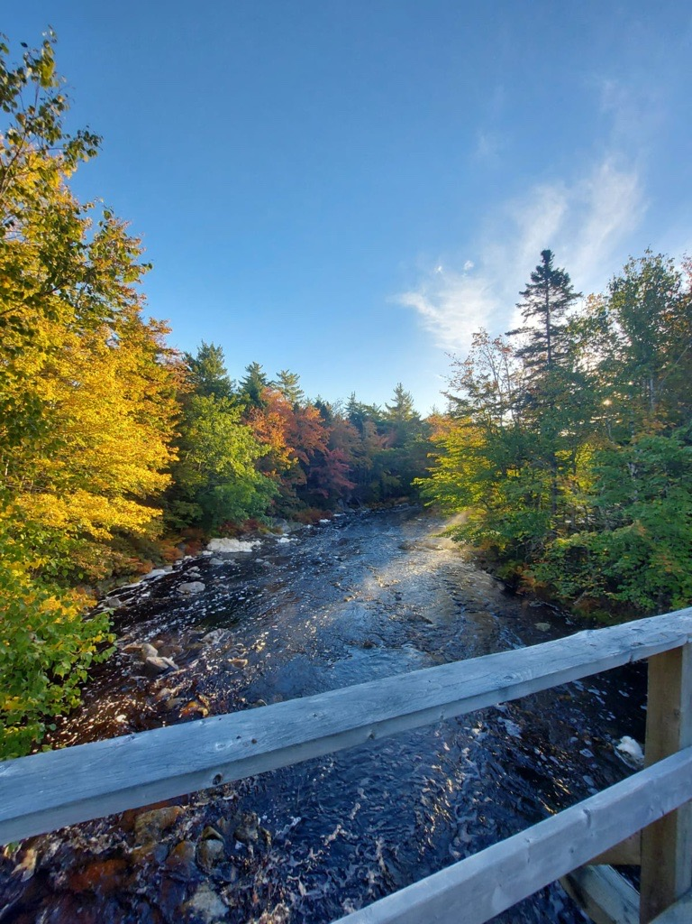

**INLAND WATER QUALITY REPORT**

|  |  |  |  |  |
| --- | --- | --- | --- | --- |
|  | **Prepared By**  Nicole Torrie  Danielle Dempsey  Rachel Woodside  Therese Wilson  Jenny Weitzman | **Date**  October 2025 | **Version**  V1 | **Contact**  P: 1-902-442-4660  E: info@cmar.ca  W: www.cmar.ca |

Table of Contents

1 Introduction 3

1.1 Data Collection 4

1.2 Quality Control 7

2 Inland Water Quality Data 8

2.1 Gold River 8

2.1.1 Gold River 2 9

2.2 Grand River 10

2.2.1 Grand River 1 11

2.2.2 Grand River 2 11

2.2.3 Grand River 3 12

2.3 Hourglass Lake 13

2.3.1 Hourglass Lake 14

2.4 LaHave River 15

2.4.1 LaHave River 1 16

2.4.2 LaHave River 2 16

2.4.3 LaHave River 3 17

2.5 Liscomb River 18

2.5.1 Liscomb River 1 19

2.5.2 Liscomb River 2 19

2.6 Mersey River 20

2.6.1 Mersey River 2 21

2.6.2 Mersey River 3 21

2.7 Meteghan River 22

2.7.1 Meteghan River 1 23

2.7.2 Meteghan River 2 23

2.7.3 Meteghan River 3 24

2.8 Middle River 25

2.8.1 Middle River 1 26

2.8.2 Middle River 2 26

2.8.3 Middle River 3 27

2.9 Musquodoboit River 28

2.9.1 Musquodoboit River 1 29

2.9.2 Musquodoboit River 2 29

2.9.3 Musquodoboit River 3 30

2.10 North River 31

2.10.1 North River 1 31

2.11 Piper Lake 32

2.11.1 Piper Lake 33

2.12 Roseway River 34

2.12.1 Roseway River 1 35

2.12.2 Roseway River 2 35

2.13 Round Hill River 36

2.13.1 Round Hill River 1 37

2.13.2 Round Hill River 2 37

2.13.3 Round Hill River 3 38

2.14 Salmon River 39

2.14.1 Salmon River 1 40

2.14.2 Salmon River 2 40

2.15 Sissiboo River 41

2.15.1 Sissiboo River 41

2.16 Tusket River 43

2.16.1 Tusket River 1 44

2.16.2 Tusket River 2 44

2.16.3 Tusket River 3 45

3 Data Acknowledgement 46

4 Document History 46

5 References 46

# Introduction

The Centre for Marine Applied Research (CMAR) measures [essential ocean variables](https://goosocean.org/what-we-do/framework/essential-ocean-variables/) around the coast of Nova Scotia through the Coastal Monitoring Program. The Nova Scotia Department of Fisheries and Aquaculture started this program in 2015 to inform aquaculture site selection and management. CMAR assumed responsibility for the program in 2019 and has since expanded its scope and mandate. Recently, CMAR began monitoring on inland waterbodies in Nova Scotia. For more information on CMAR and the Coastal Monitoring Program, visit the [CMAR website](https://cmar.ca/).

This document presents deployment details and summary figures of inland Water Quality data collected in Nova Scotia (Figure 1). The data are available for download from the Nova Scotia [Open Data Portal](https://data.novascotia.ca/browse?q=coastal+monitoring+program&sortBy=relevance&limitTo=datasets&tags=water+quality).

This document should be considered as a guide only. Data collection and retrieval are ongoing. The information may be revised pending ongoing data collection and analyses.

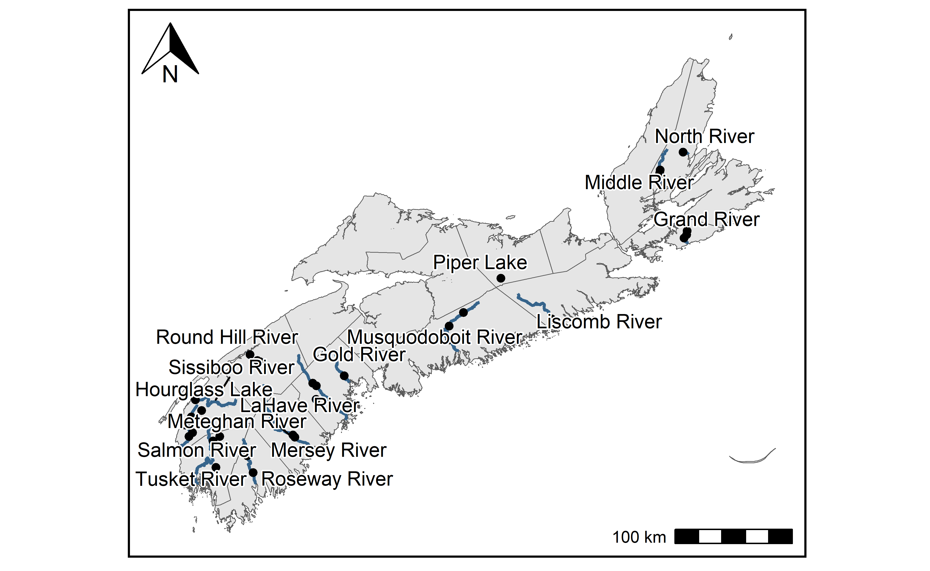

**Figure 1:** Inland Water Quality sampling station locations.

## Data Collection

CMAR primarily collects inland Water Quality data using sensors secured inside a perforated PVC housing and anchored to the riverbed by a cinderblock (Figure 2). Sensors are usually deployed in 1.5m depths or shallower, and accessed by foot.

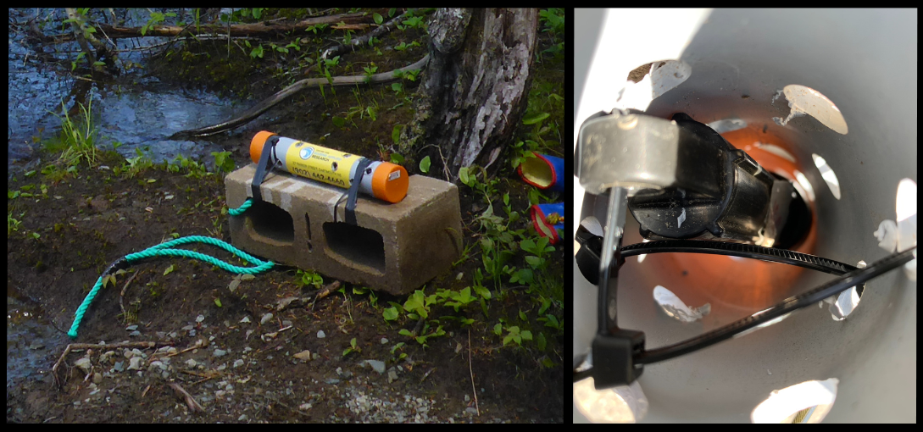

**Figure 2:** Images of a temperature sensor deployed with a cinderblock anchor. Left: perforated PVC sensor housing attached to cinderblock. Right: Hobo U22 Temperature sensor secured inside PVC sensor housing.

CMAR occasionally collects inland temperature and dissolved oxygen data using moorings referred to as “sensor strings”. A typical sensor string configuration consists of a rope attached to the seafloor by an anchor and suspended by a sub-surface buoy, with sensors attached at various depths (Figure 3). Alternatively, sensors may be attached to floating docks, surface buoys, equipment, or fixed structures (Table 1).

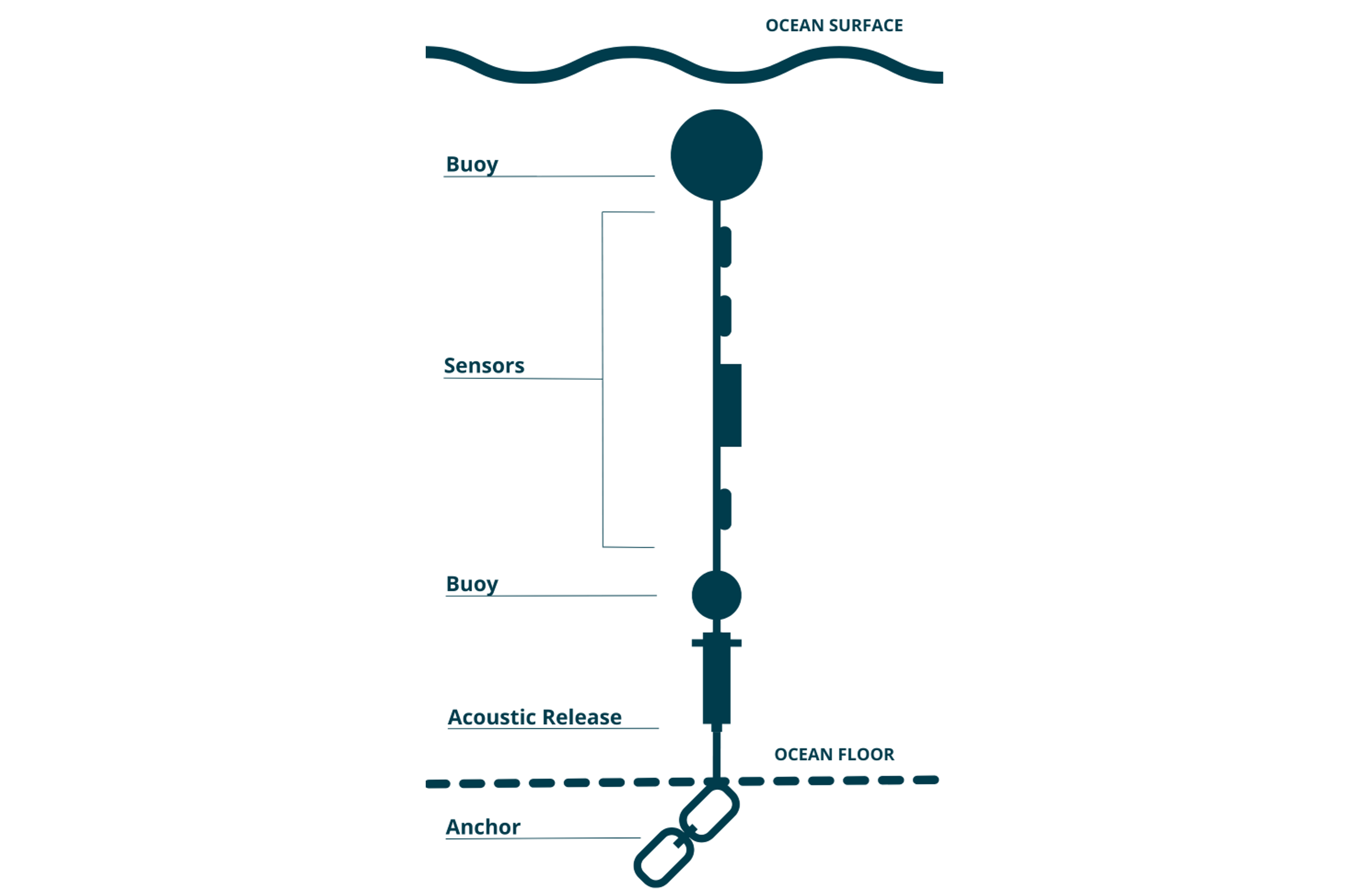

**Figure 3:** Example sensor string configuration (not to scale).

Sensors are typically deployed at a station for several months to a year, and data are logged every 1 minute to 1 hour. Sensors must be retrieved to offload the data. The retrieval method depends on the sensor configuration, and may include triggering an acoustic release, directly removing sensors from surface moorings, or removing shallow water bottom-mounted sensors on foot (Table 1).

**Table 1:** Description of sensor string configurations.

| Configuration | Description |
| --- | --- |
| Sub-surface buoy | Attached to sub-surface buoy. Typically has an acoustic release, but sometimes retrieved by diver or drag line. Does not float with the tide or water level fluctuations. |
| Surface buoy | Attached to a surface buoy. Floats with the tide or water level fluctuations. |
| Attached to gear | Typically attached to aquaculture gear[1], but may be attached to another structure. Floats with the tide or water level fluctuations. |
| Attached to fixed structure | Typically attached to a wharf, but may be attached to a bridge, cinderblock, or pole. Does not float with the tide or water level fluctuations. |
| Floating dock | Attached to a floating dock. Floats with the tide or water level fluctuations. |
| Unknown | Configuration not indicated in historical deployment log. |

Interest-holder needs and characteristics of the station dictate the deployment design, including anchor weight, number and type of sensors, and configuration (Table 1).

## Quality Control

Automated Quality Control tests were applied to the data to identify outlying and unexpected observations. Following Quality Assurance/Quality Control of Real-Time Oceanographic Data (QARTOD) guidance, each data point was assigned a flag of “Pass”, “Fail”, “Suspect/Of Interest”, or “Not Evaluated” (IOOS 2020). These automated flags were reviewed by human experts, and modified where necessary (e.g., upgrading “Suspect/Of Interest” flags to “Fail” if there were known issues with the deployment). CMAR does not currently have enough inland data to conduct as thorough an analysis to develop test thresholds as was done on the coastal Water Quality data. Inland thresholds may be picked in more subjective ways.

Observations flagged as “Pass” passed all tests and were included in the figures below. “Suspect/Of Interest” dissolved oxygen observations may be indicative of sensor biofouling. “Suspect/Of Interest” temperature observations may be indicative of sensor exposure to air during periods of low water, or rapid changes in temperature due to a rainfall event. Most of the flagged “Suspect/Of Interest” observations were considered “Of Interest” and are shown in the figures below. Observations that failed any test were considered poor quality data and excluded from the figures.

Some tests cannot be applied to certain observations, which were flagged as “Not Evaluated”. These data points were not included in the figures.

Removing flagged observations can result in patchy time series. The full inland Water Quality Datasets, including Quality Control flags, can be downloaded from the [Open Data Portal](https://data.novascotia.ca/browse?q=coastal+monitoring+program&sortBy=relevance&limitTo=datasets&tags=water+quality). Data gaps can also be caused by battery failure, delays between retrieval and re-deployment, and accidental or intentional interference with equipment.

Note that some sensors may drift over time. The existing Quality Control tests do not explicitly detect sensor drift, and users should review all data prior to use.

For more technical details about the Quality Control tests, visit the CMAR [Data Governance website](https://dempsey-cmar.github.io/cmp-data-governance/pages/cmp_about.html).

# Inland Water Quality Data

Inland Water Quality data is presented by waterbody. For each waterbody, there is a table of deployment details followed by figures showing the station locations and the data at each station. Note the differences in scales between figures (x-axis, y-axis, and colour). Some sensors may have been deployed in tributaries of the named deployment waterbody. Take note of exact station coordinates prior to conducting analysis.

## Gold River

**Table 2:** Deployment details for Gold River.

| Station | Deployment Date | Retrieval Date | Latitude | Longitude | Configuration | Variables Measured |
| --- | --- | --- | --- | --- | --- | --- |
| Gold River 2 | 2023-06-13 | 2023-10-04 | 44.5964 | -64.3724 | attached to fixed structure | temperature |

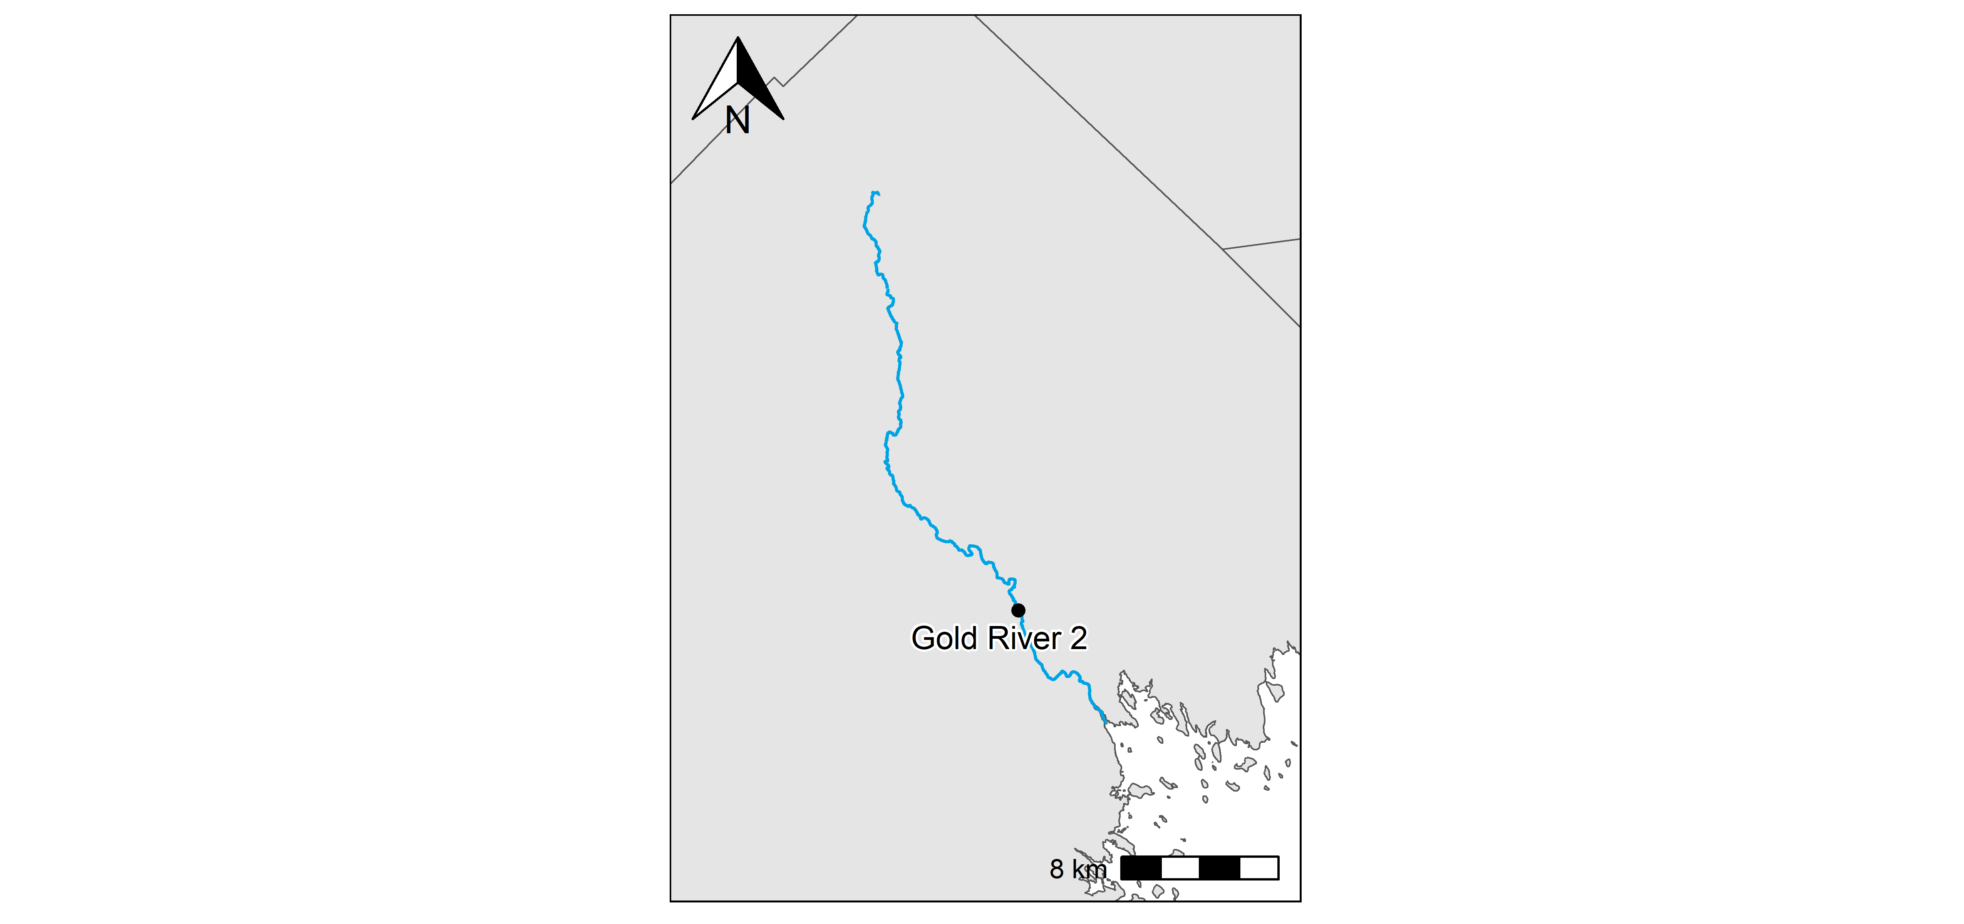**Figure 5:** Gold River station locations.

### Gold River 2

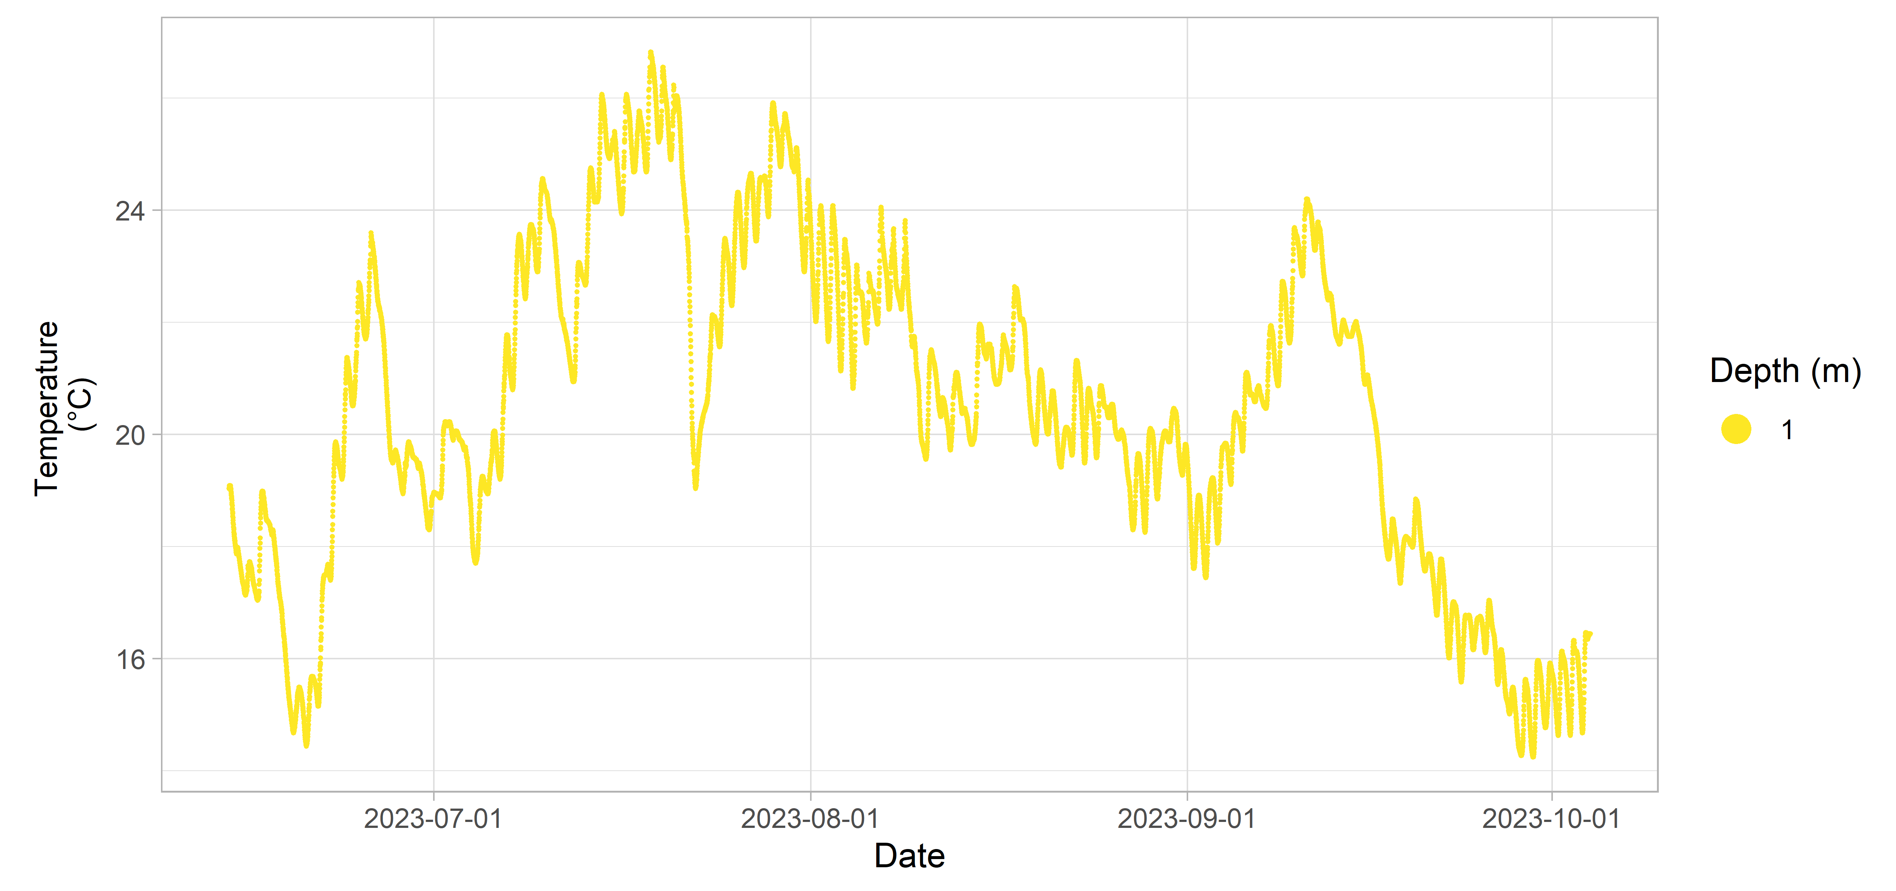**Figure 6:** Gold River 2 inland Water Quality data.

## Grand River

**Table 3:** Deployment details for Grand River.

| Station | Deployment Date | Retrieval Date | Latitude | Longitude | Configuration | Variables Measured |
| --- | --- | --- | --- | --- | --- | --- |
| Grand River 1 | 2024-06-10 | 2024-09-30 | 45.6556 | -60.6599 | attached to fixed structure | temperature |
| Grand River 2 | 2024-06-10 | 2024-09-30 | 45.6809 | -60.6313 | attached to fixed structure | temperature |
| Grand River 3 | 2024-06-10 | 2024-09-30 | 45.7107 | -60.6262 | attached to fixed structure | temperature |

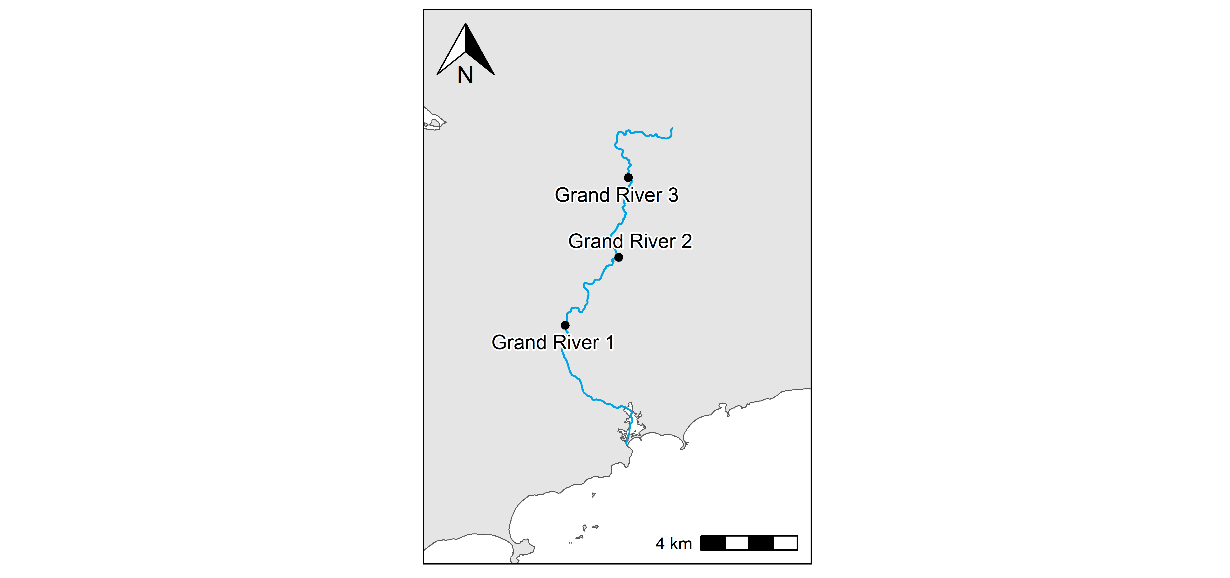**Figure 7:** Grand River station locations.

### Grand River 1

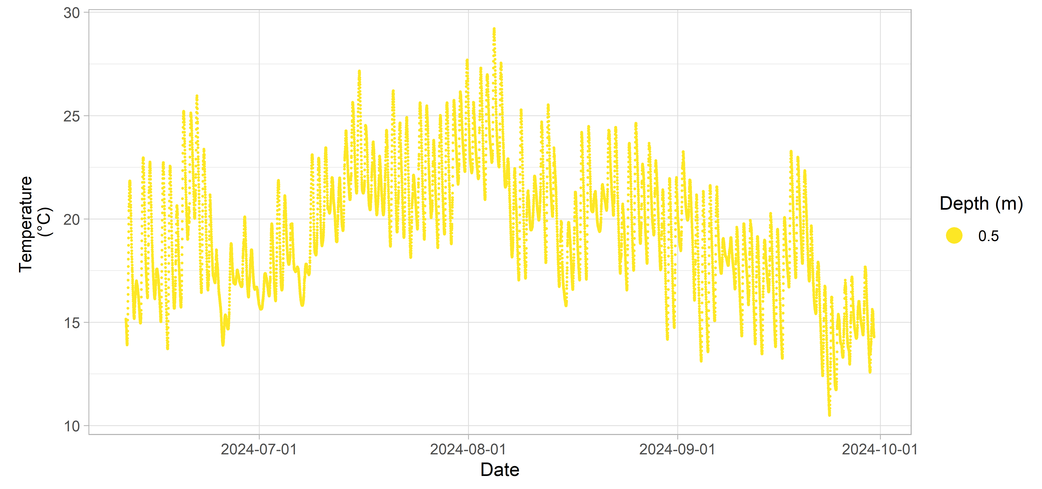**Figure 8:** Grand River 1 inland Water Quality data.

### Grand River 2

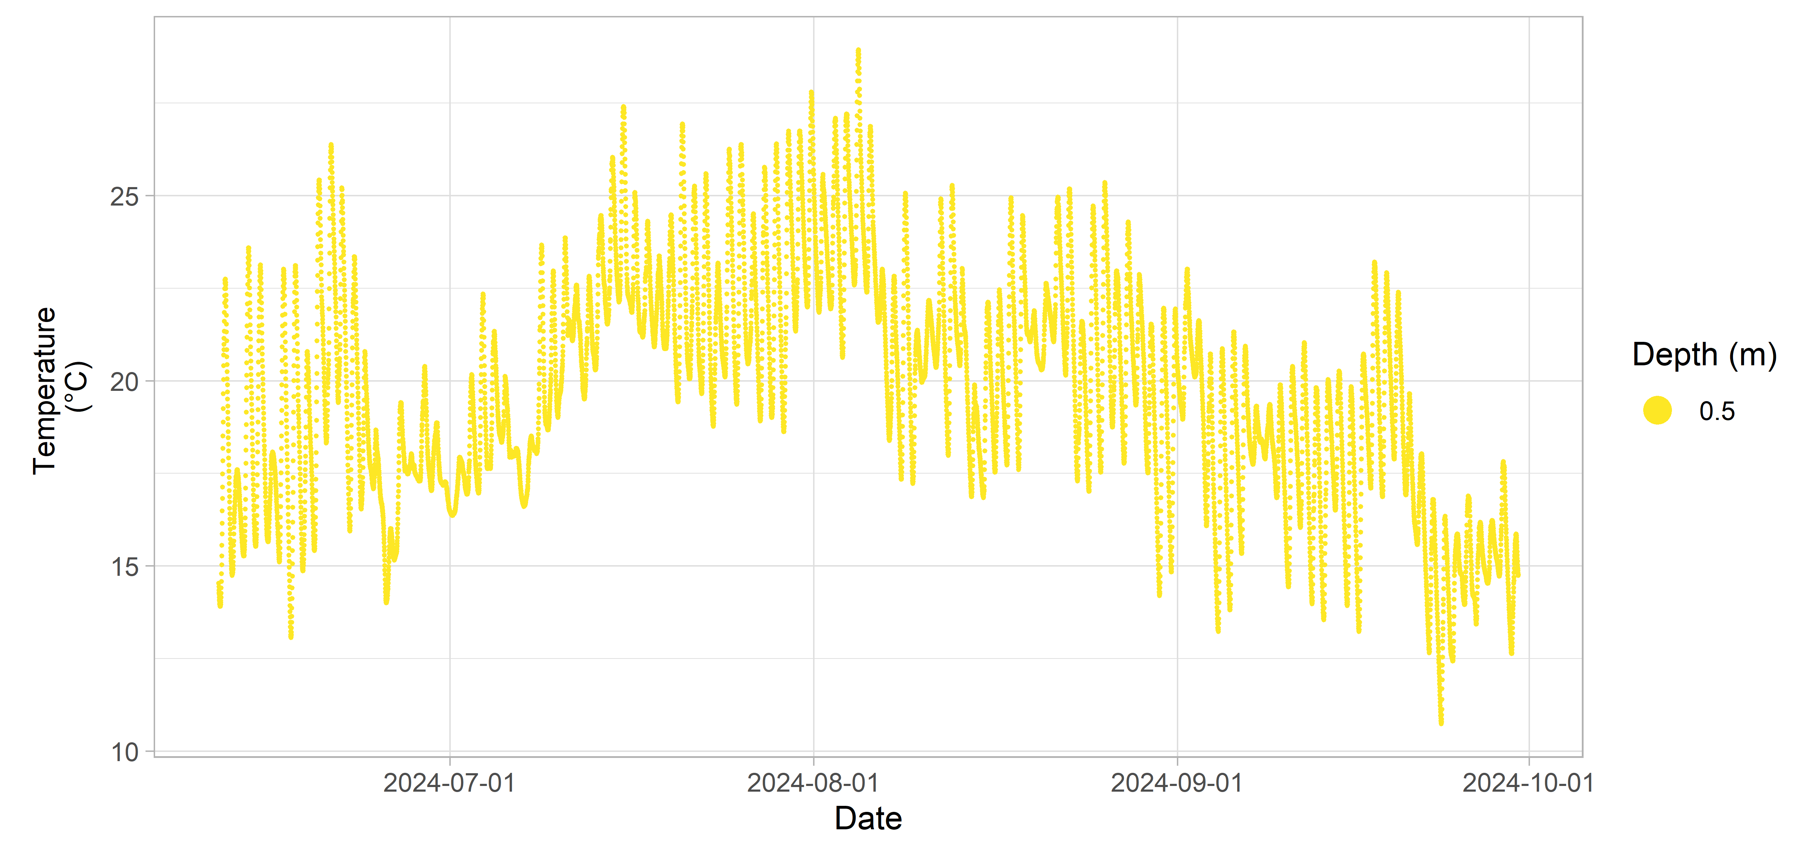**Figure 9:** Grand River 2 inland Water Quality data.

### Grand River 3

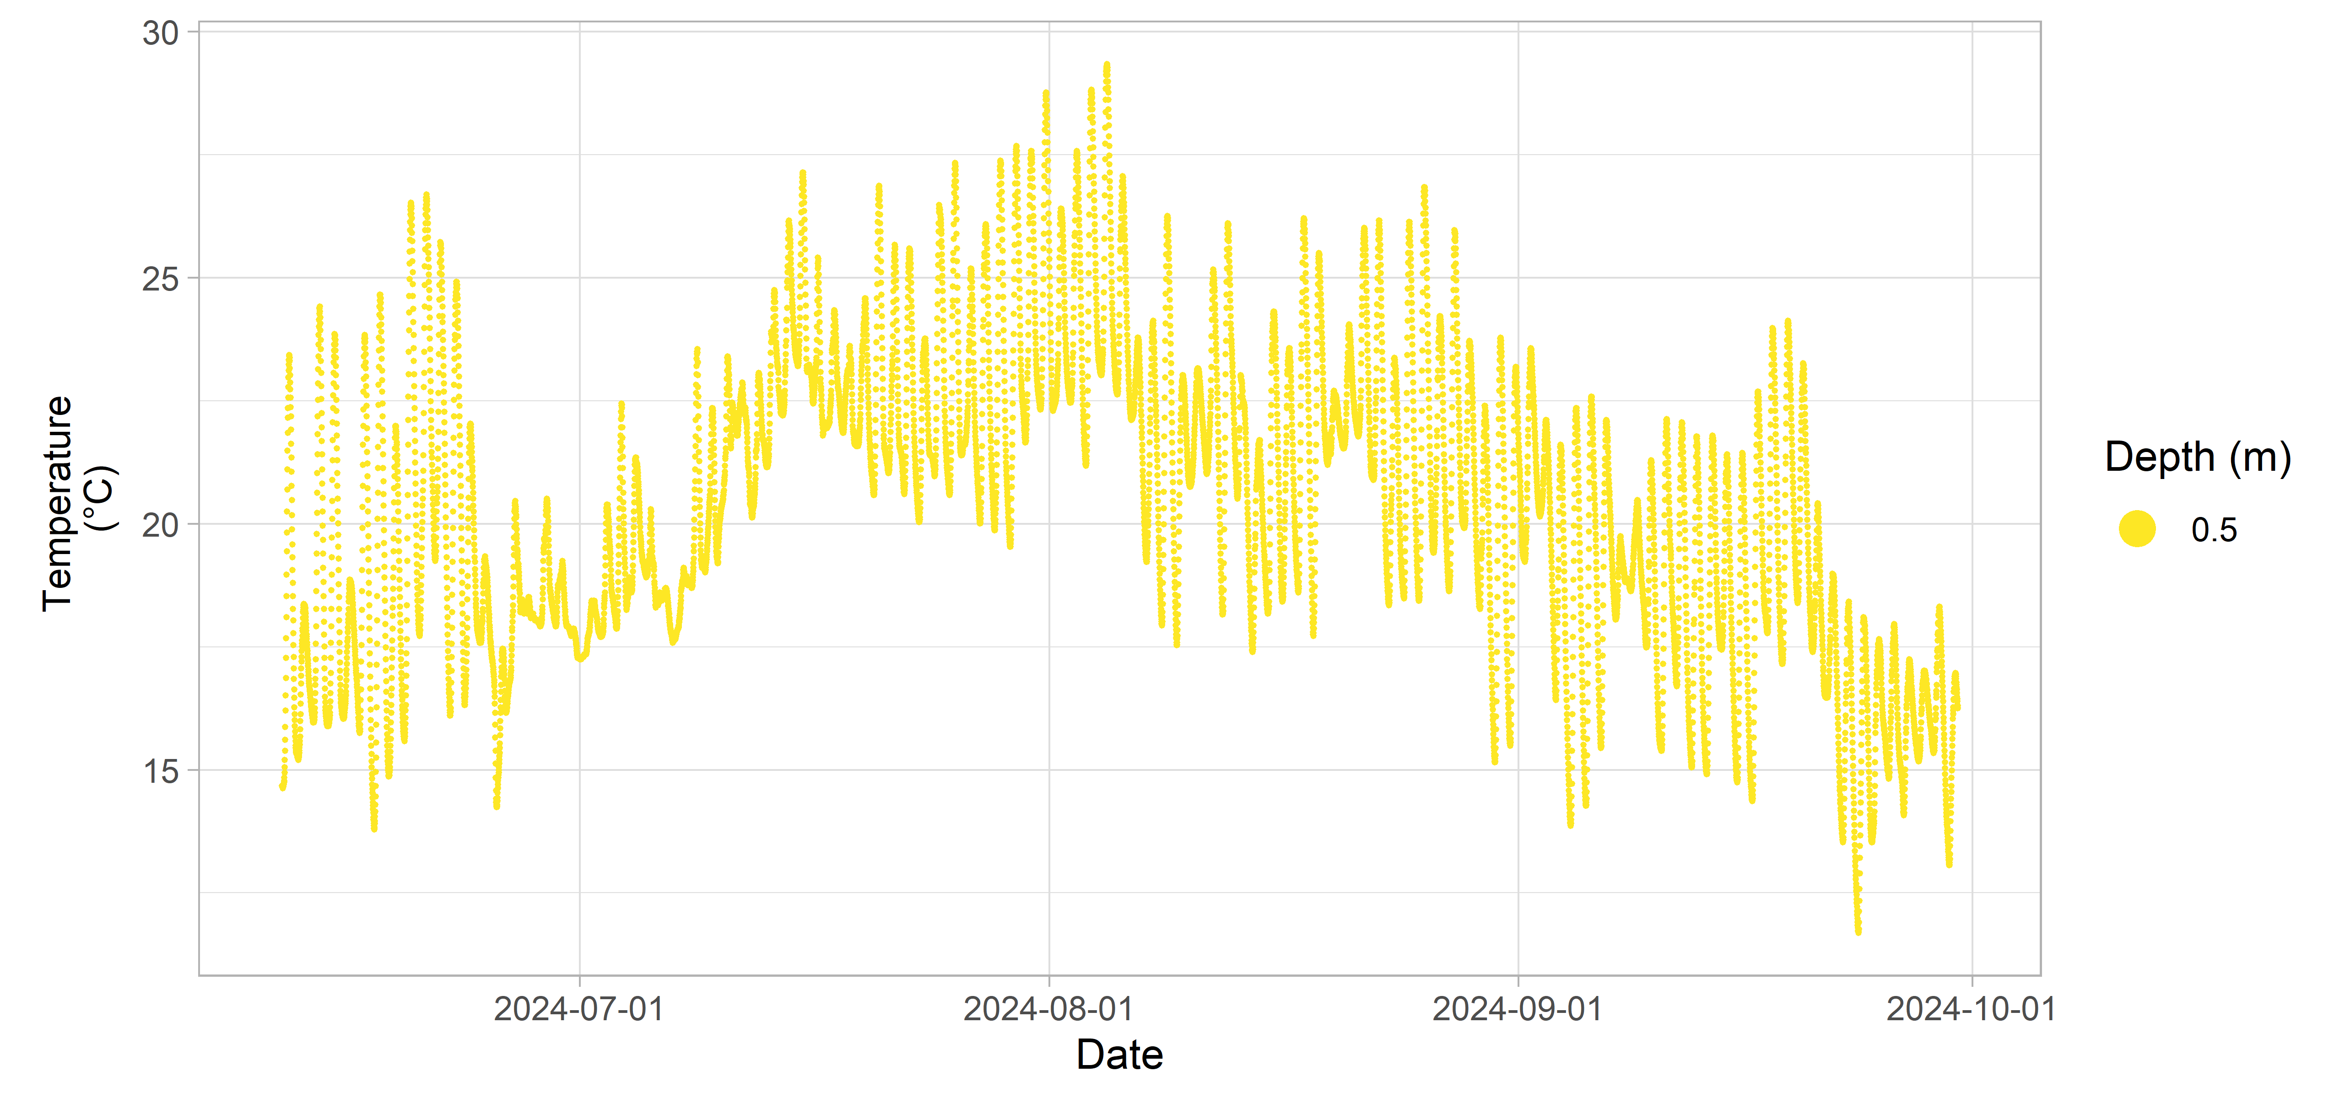**Figure 10:** Grand River 3 inland Water Quality data.

## Hourglass Lake

**Table 4:** Deployment details for Hourglass Lake.

| Station | Deployment Date | Retrieval Date | Latitude | Longitude | Configuration | Variables Measured |
| --- | --- | --- | --- | --- | --- | --- |
| Hourglass Lake | 2019-10-02 | 2020-07-23 | 44.3279 | -65.9282 | sub-surface buoy | dissolved oxygen (% sat) |
| temperature |  |  |  |  |  |  |

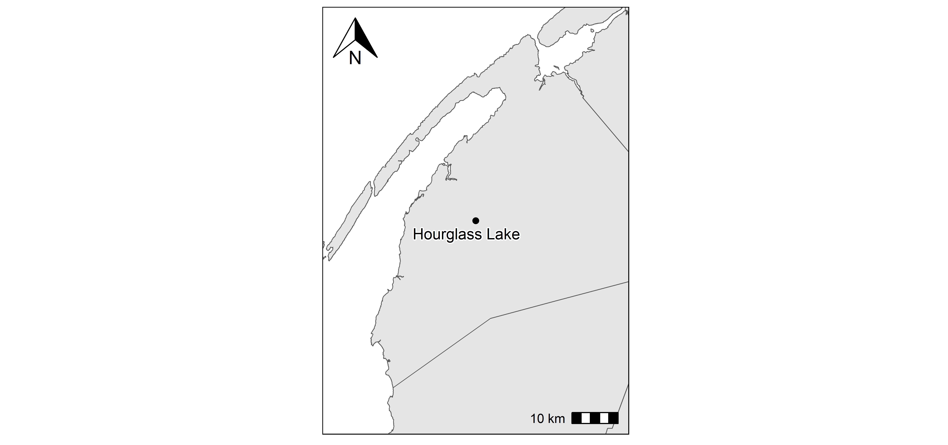**Figure 11:** Hourglass Lake station locations.

### Hourglass Lake

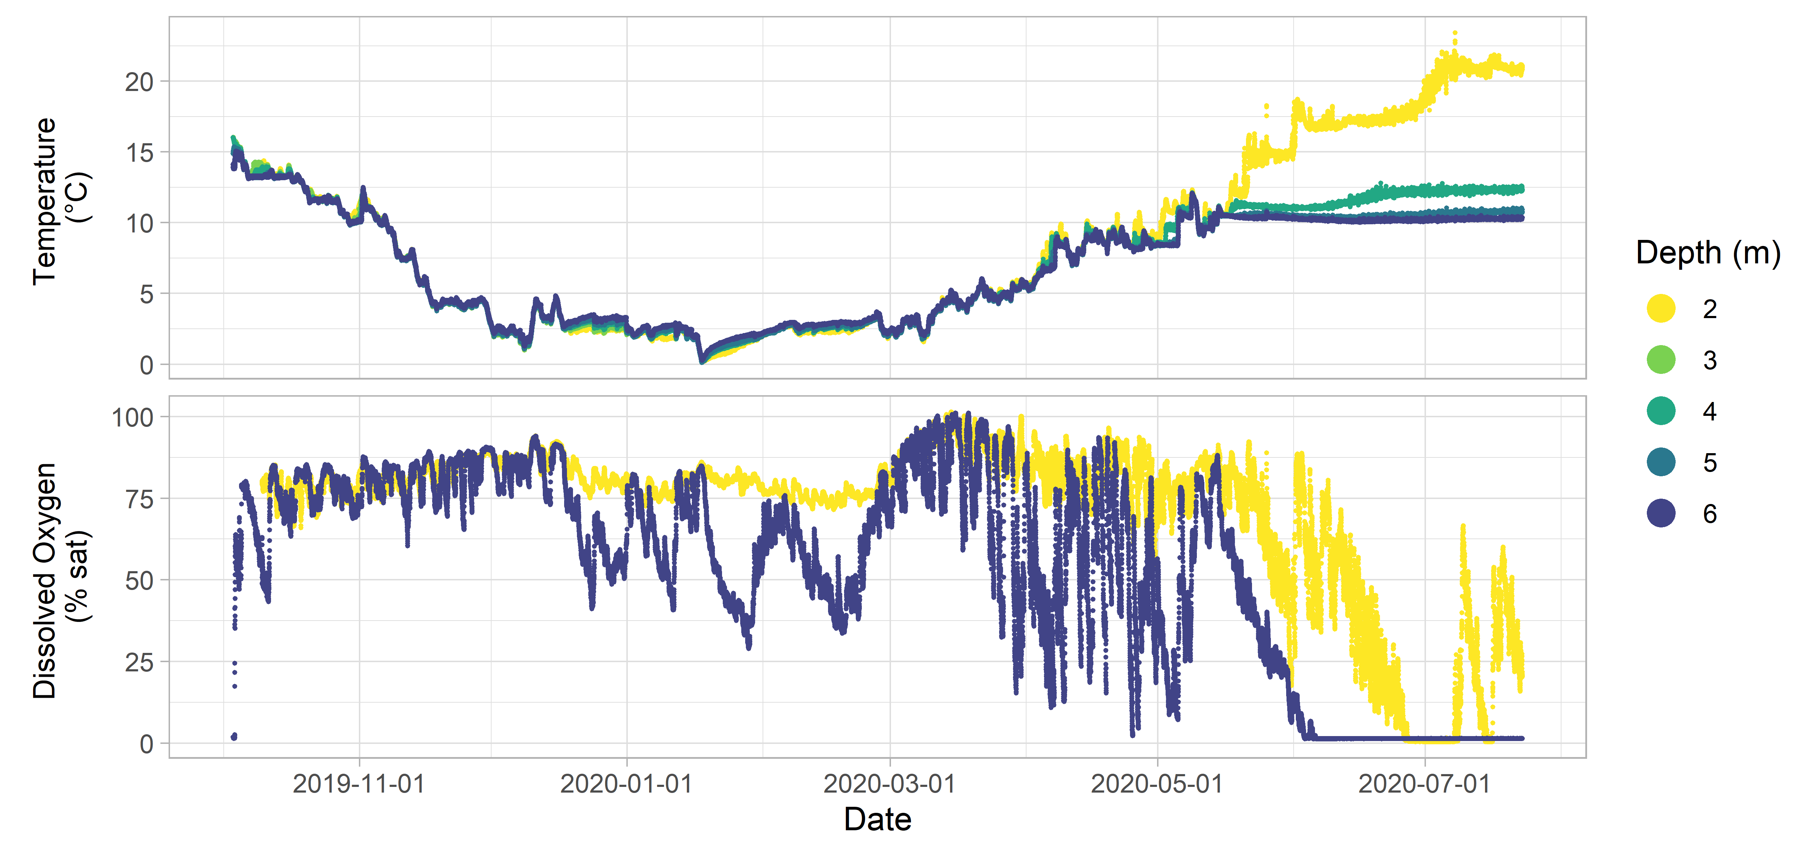**Figure 12:** Hourglass Lake inland Water Quality data.

## LaHave River

**Table 5:** Deployment details for LaHave River.

| Station | Deployment Date | Retrieval Date | Latitude | Longitude | Configuration | Variables Measured |
| --- | --- | --- | --- | --- | --- | --- |
| LaHave River 1 | 2023-06-20 | 2023-10-04 | 44.4152 | -64.6782 | attached to fixed structure | temperature |
| LaHave River 2 | 2023-06-20 | 2023-10-04 | 44.5395 | -64.7157 | attached to fixed structure | temperature |
| LaHave River 3 | 2023-06-20 | 2023-10-04 | 44.5185 | -64.6751 | attached to fixed structure | temperature |

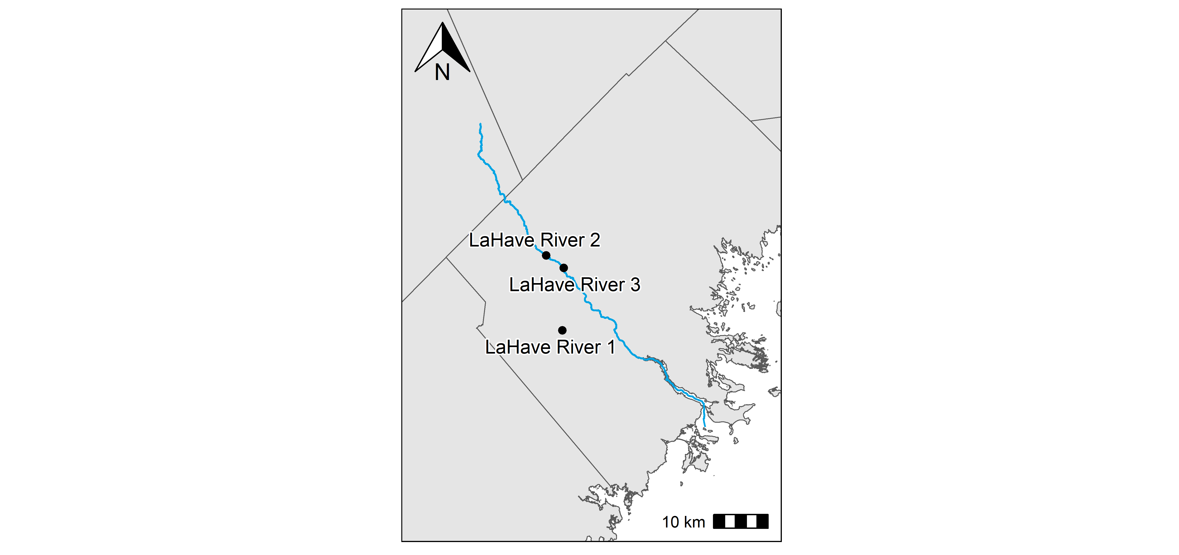**Figure 13:** LaHave River station locations.

### LaHave River 1

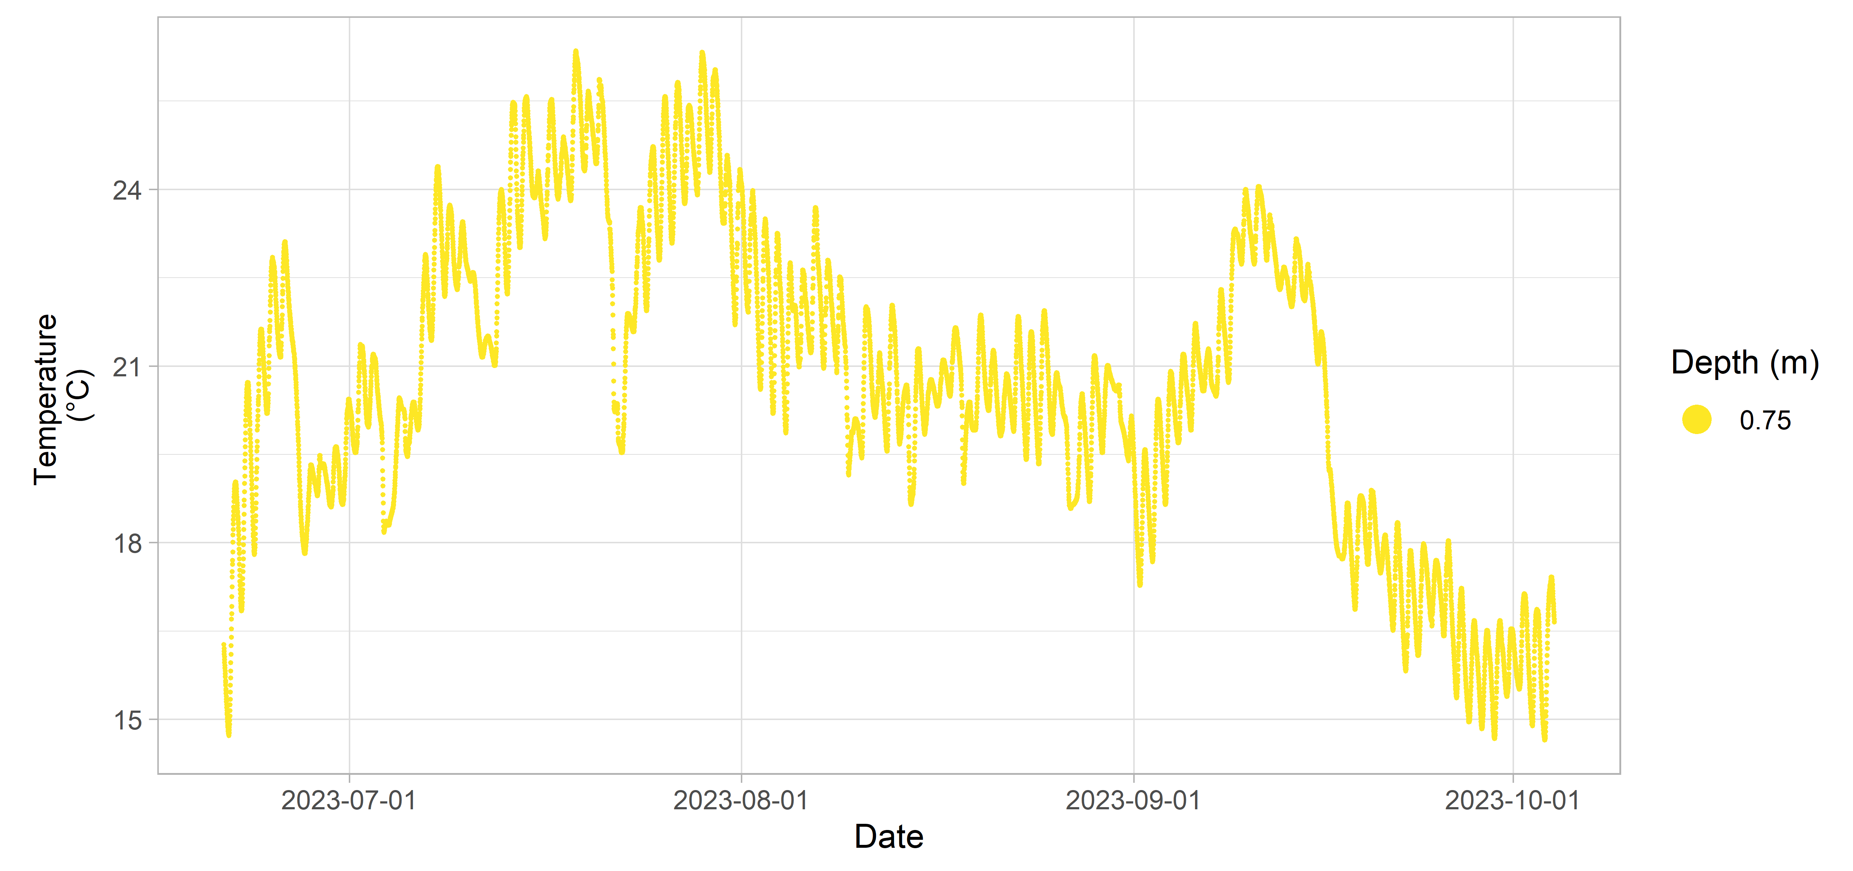**Figure 14:** LaHave River 1 inland Water Quality data.

### LaHave River 2

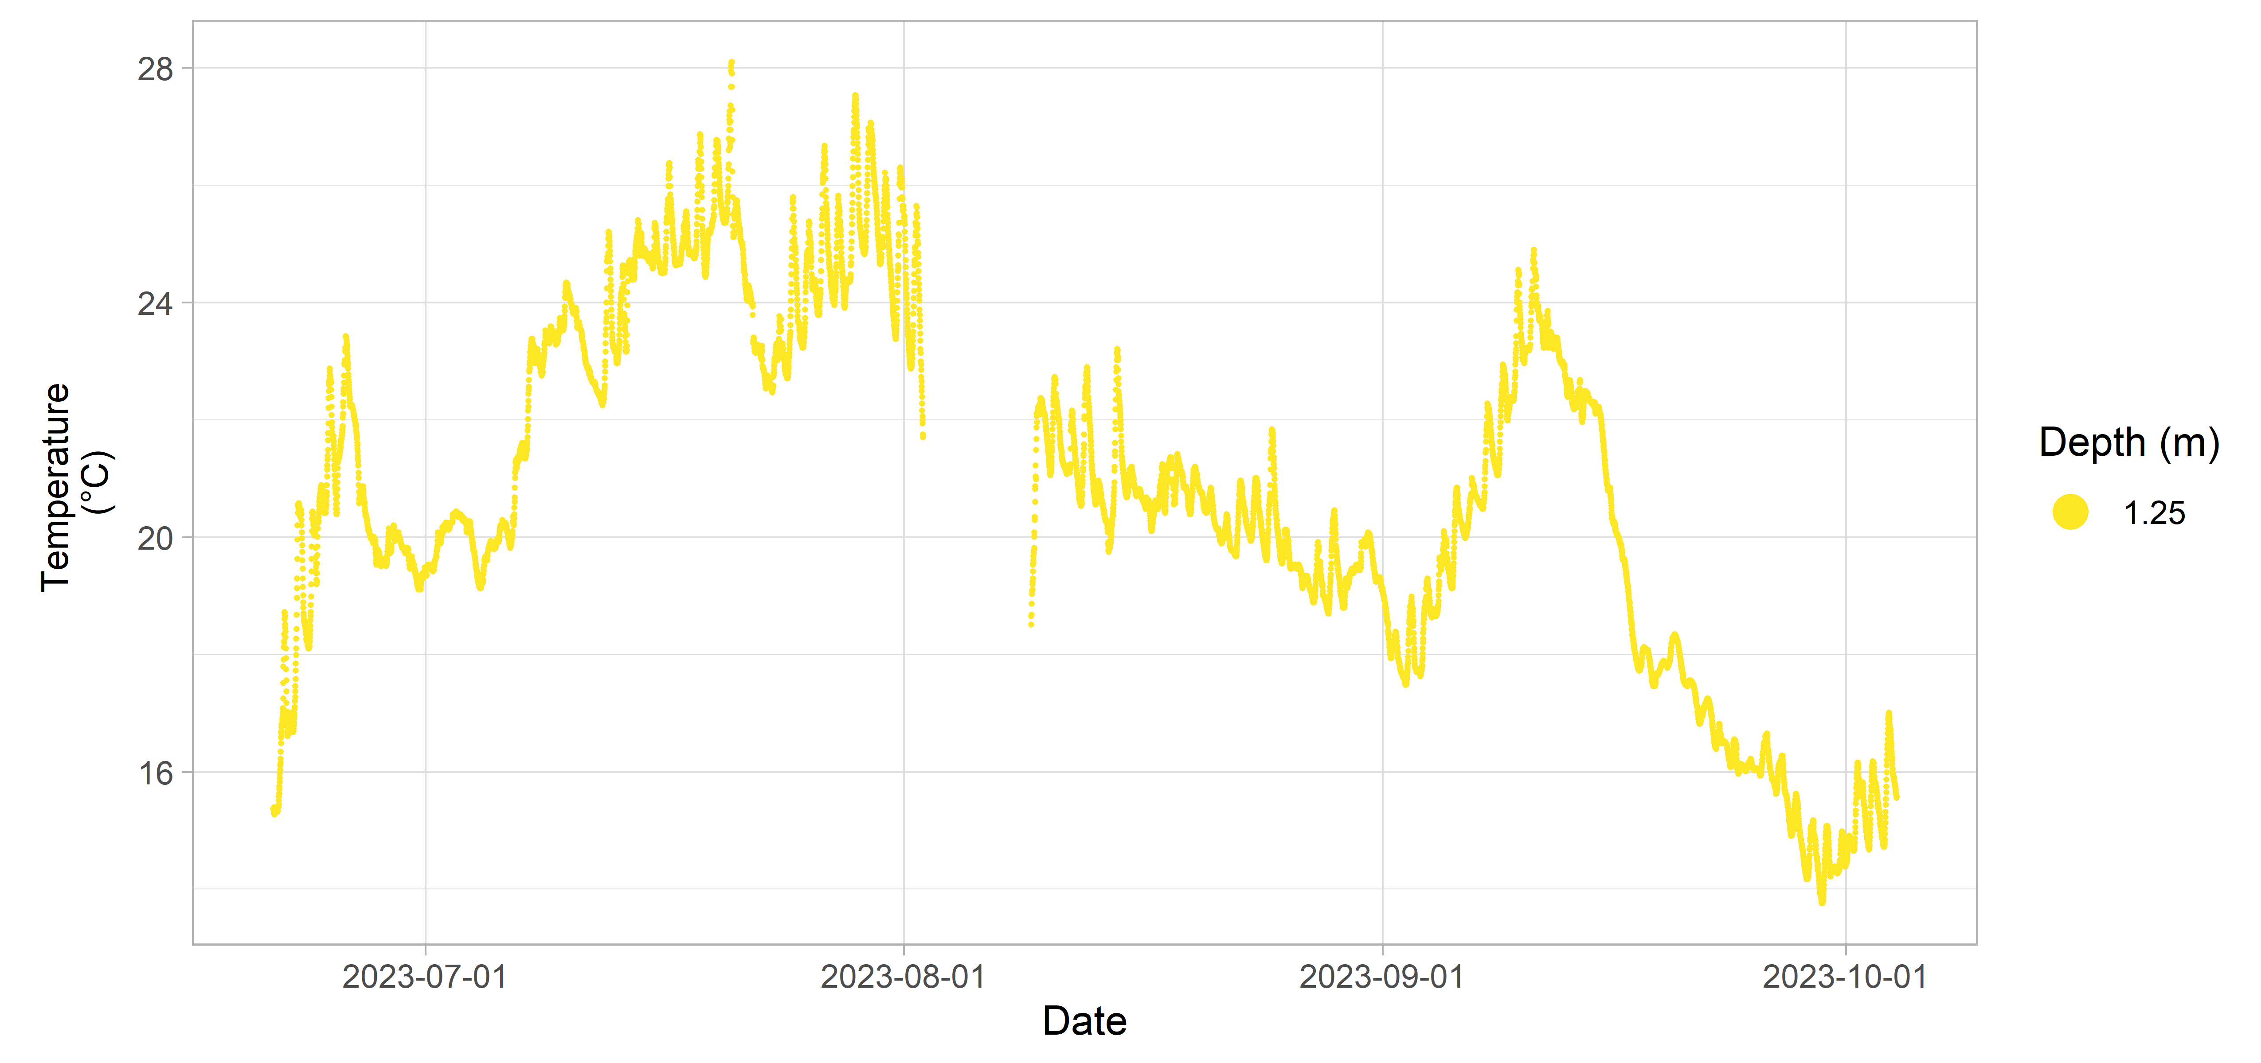**Figure 15:** LaHave River 2 inland Water Quality data.

### LaHave River 3

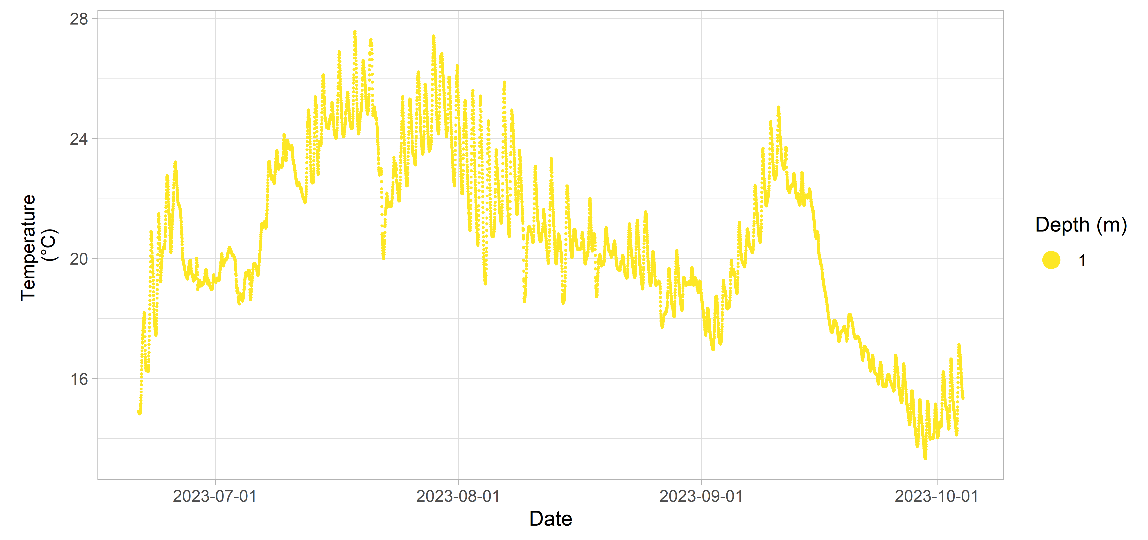**Figure 16:** LaHave River 3 inland Water Quality data.

## Liscomb River

**Table 6:** Deployment details for Liscomb River.

| Station | Deployment Date | Retrieval Date | Latitude | Longitude | Configuration | Variables Measured |
| --- | --- | --- | --- | --- | --- | --- |
| Liscomb River 1 | 2023-06-08 | 2023-10-11 | 45.0336 | -62.1052 | attached to fixed structure | temperature |
| Liscomb River 2 | 2023-06-08 | 2023-10-11 | 45.0300 | -62.1043 | attached to fixed structure | temperature |

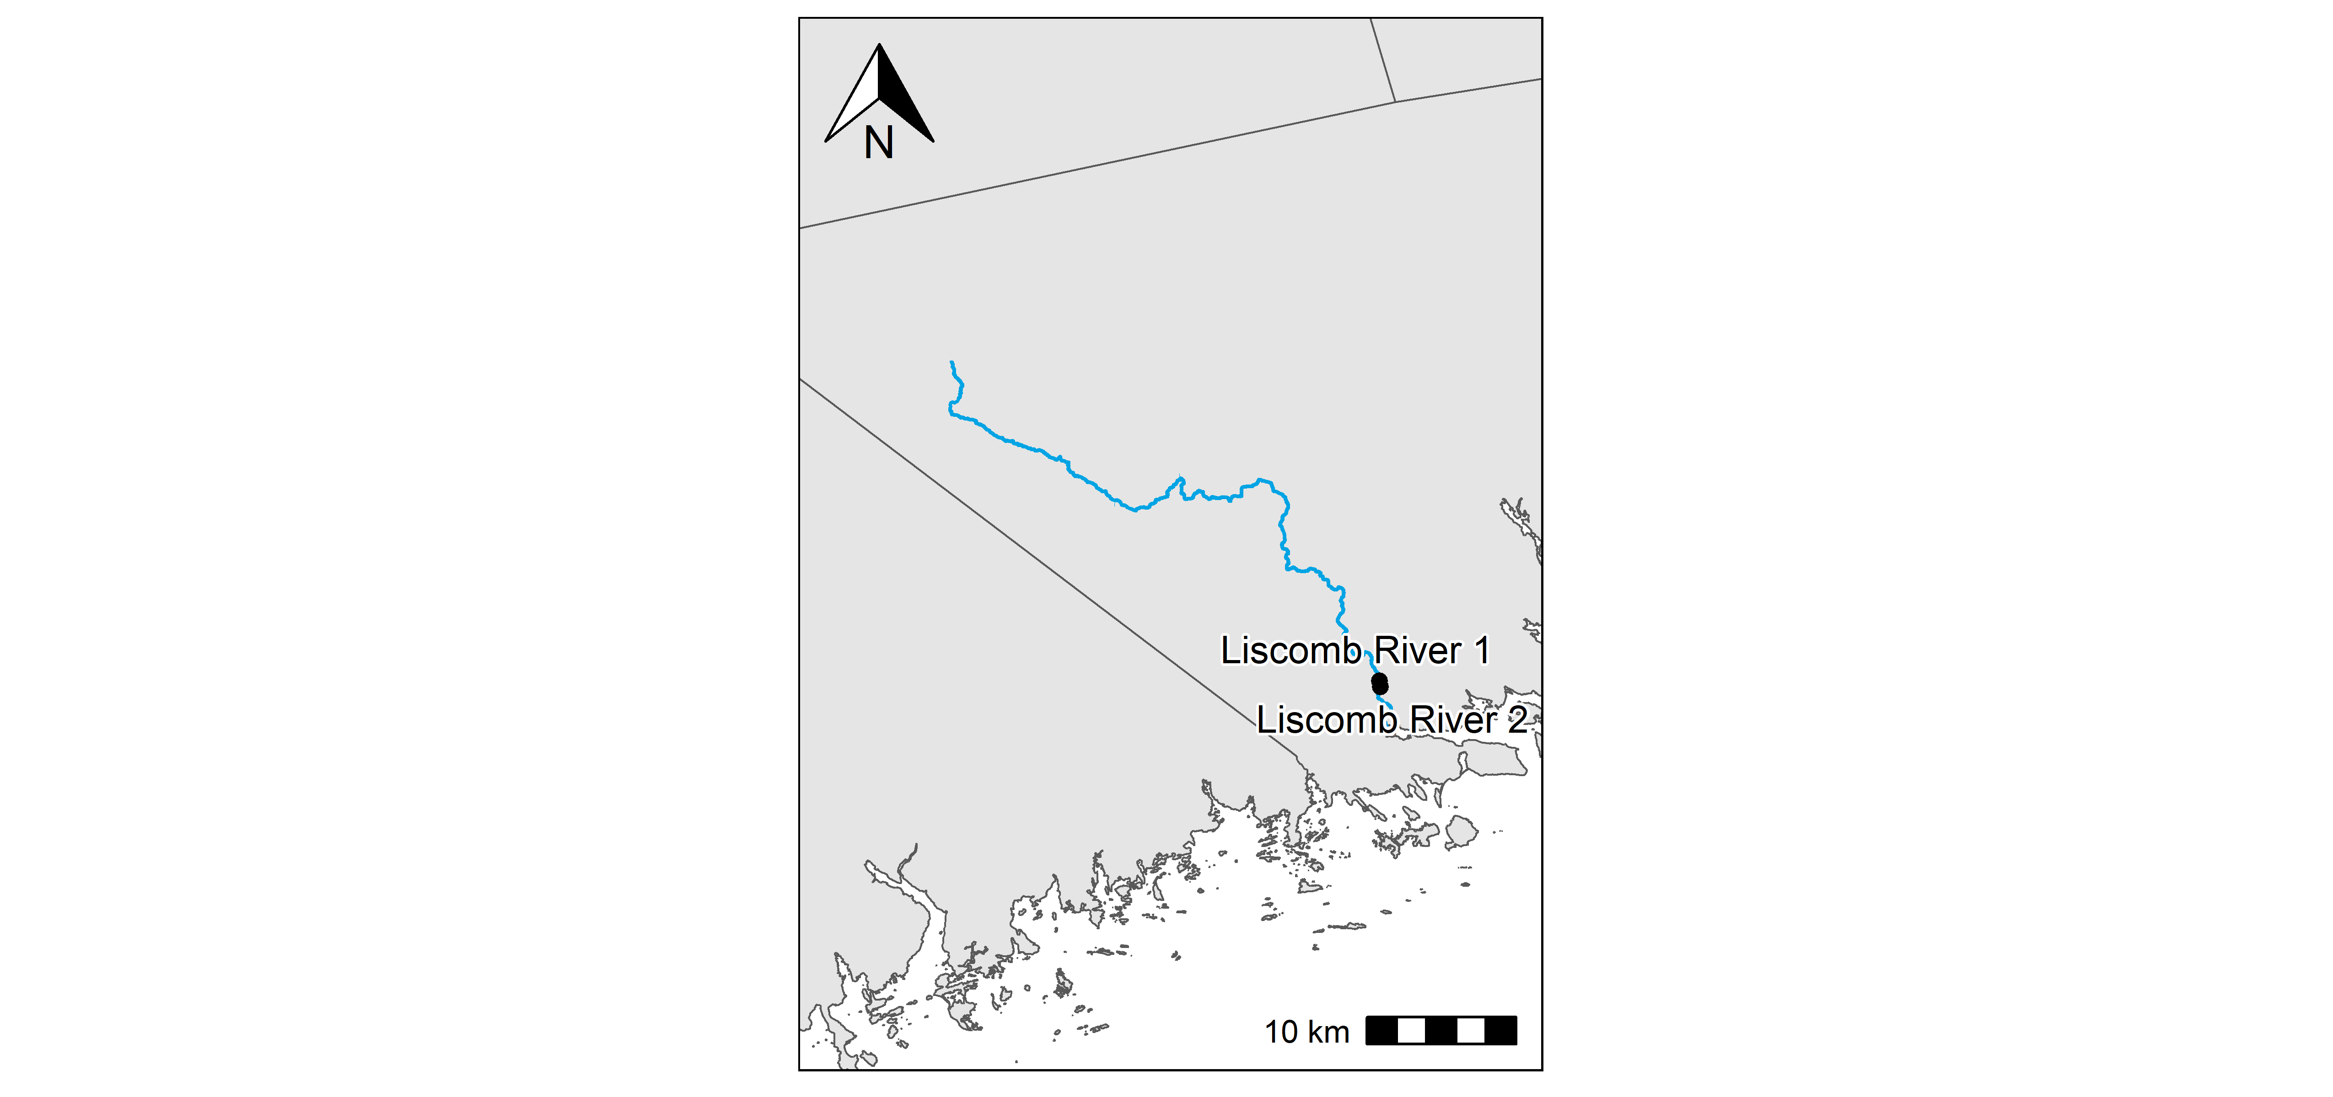**Figure 17:** Liscomb River station locations.

### Liscomb River 1

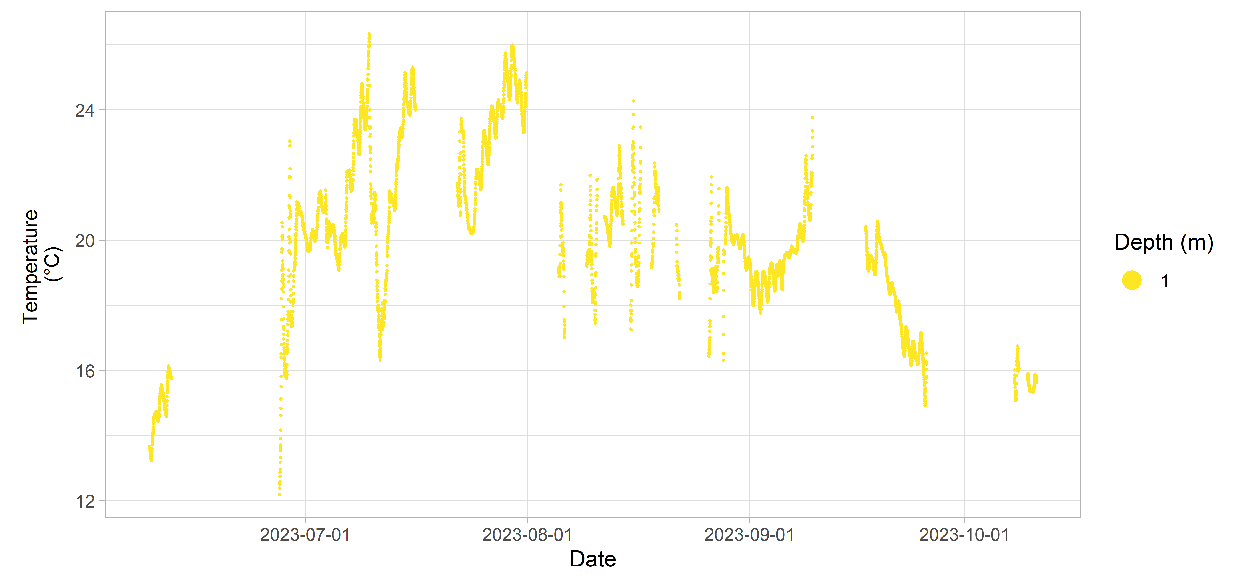**Figure 18:** Liscomb River 1 inland Water Quality data.

### Liscomb River 2

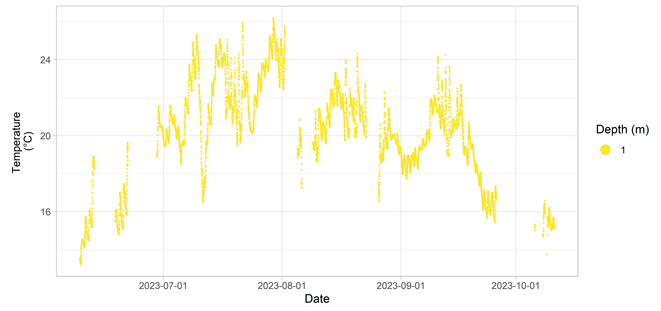**Figure 19:** Liscomb River 2 inland Water Quality data.

## Mersey River

**Table 7:** Deployment details for Mersey River.

| Station | Deployment Date | Retrieval Date | Latitude | Longitude | Configuration | Variables Measured |
| --- | --- | --- | --- | --- | --- | --- |
| Mersey River 2 | 2023-06-23 | 2023-10-13 | 44.1234 | -64.9102 | attached to fixed structure | temperature |
| Mersey River 3 | 2023-06-23 | 2024-07-03 | 44.1392 | -64.9309 | attached to fixed structure | temperature |

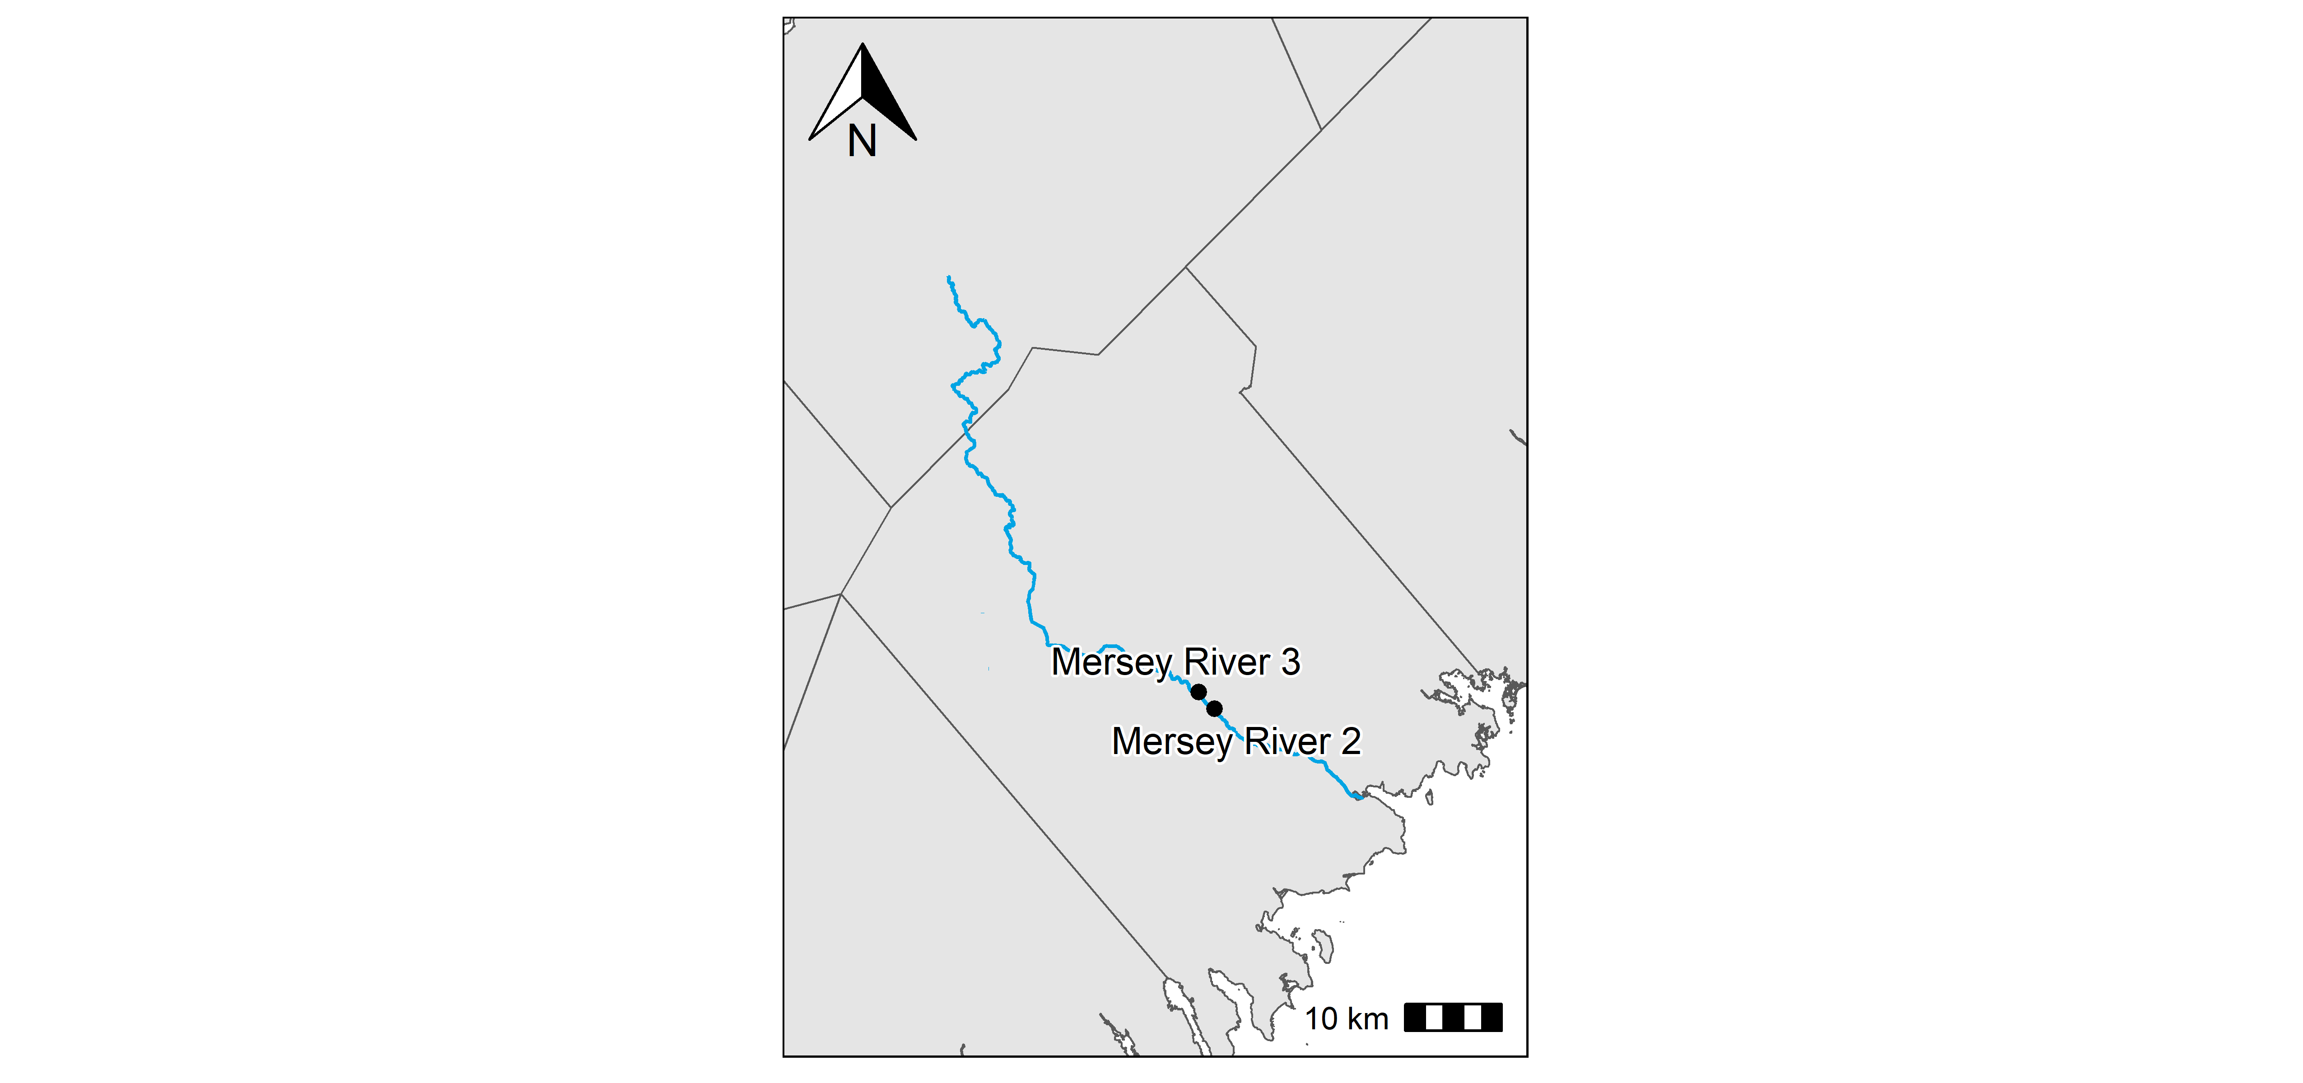**Figure 20:** Mersey River station locations.

### Mersey River 2

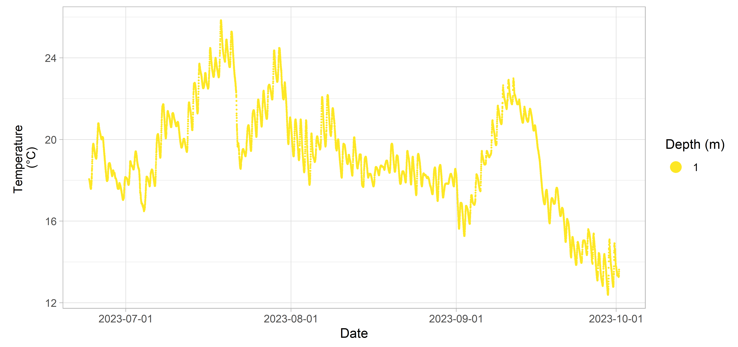**Figure 21:** Mersey River 2 inland Water Quality data.

### Mersey River 3

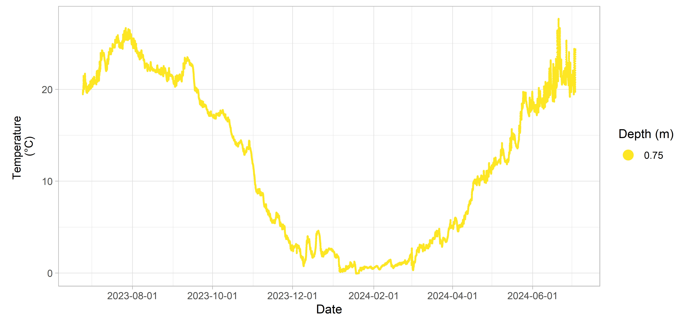**Figure 22:** Mersey River 3 inland Water Quality data.

## Meteghan River

**Table 8:** Deployment details for Meteghan River.

| Station | Deployment Date | Retrieval Date | Latitude | Longitude | Configuration | Variables Measured |
| --- | --- | --- | --- | --- | --- | --- |
| Meteghan River 1 | 2024-06-06 | 2024-10-11 | 44.2218 | -66.0696 | attached to fixed structure | temperature |
| Meteghan River 2 | 2024-06-06 | 2024-10-11 | 44.2788 | -66.0411 | attached to fixed structure | temperature |
| Meteghan River 3 | 2024-06-07 | 2024-10-11 | 44.2161 | -66.1075 | attached to fixed structure | temperature |

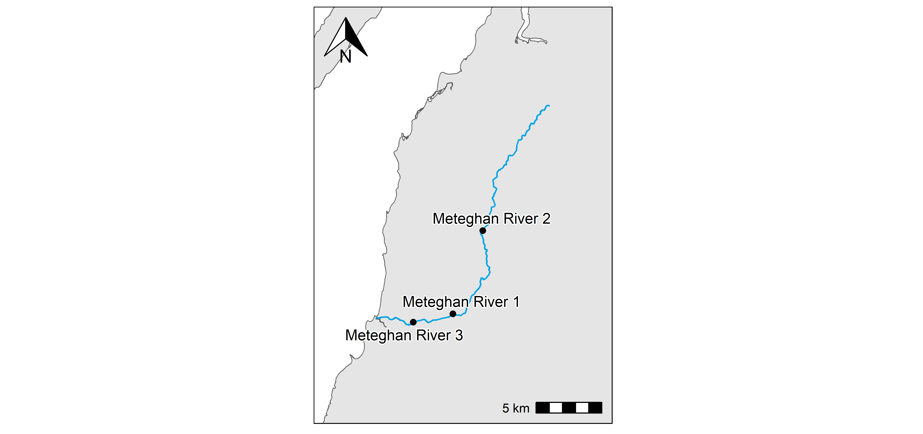**Figure 23:** Meteghan River station locations.

### Meteghan River 1

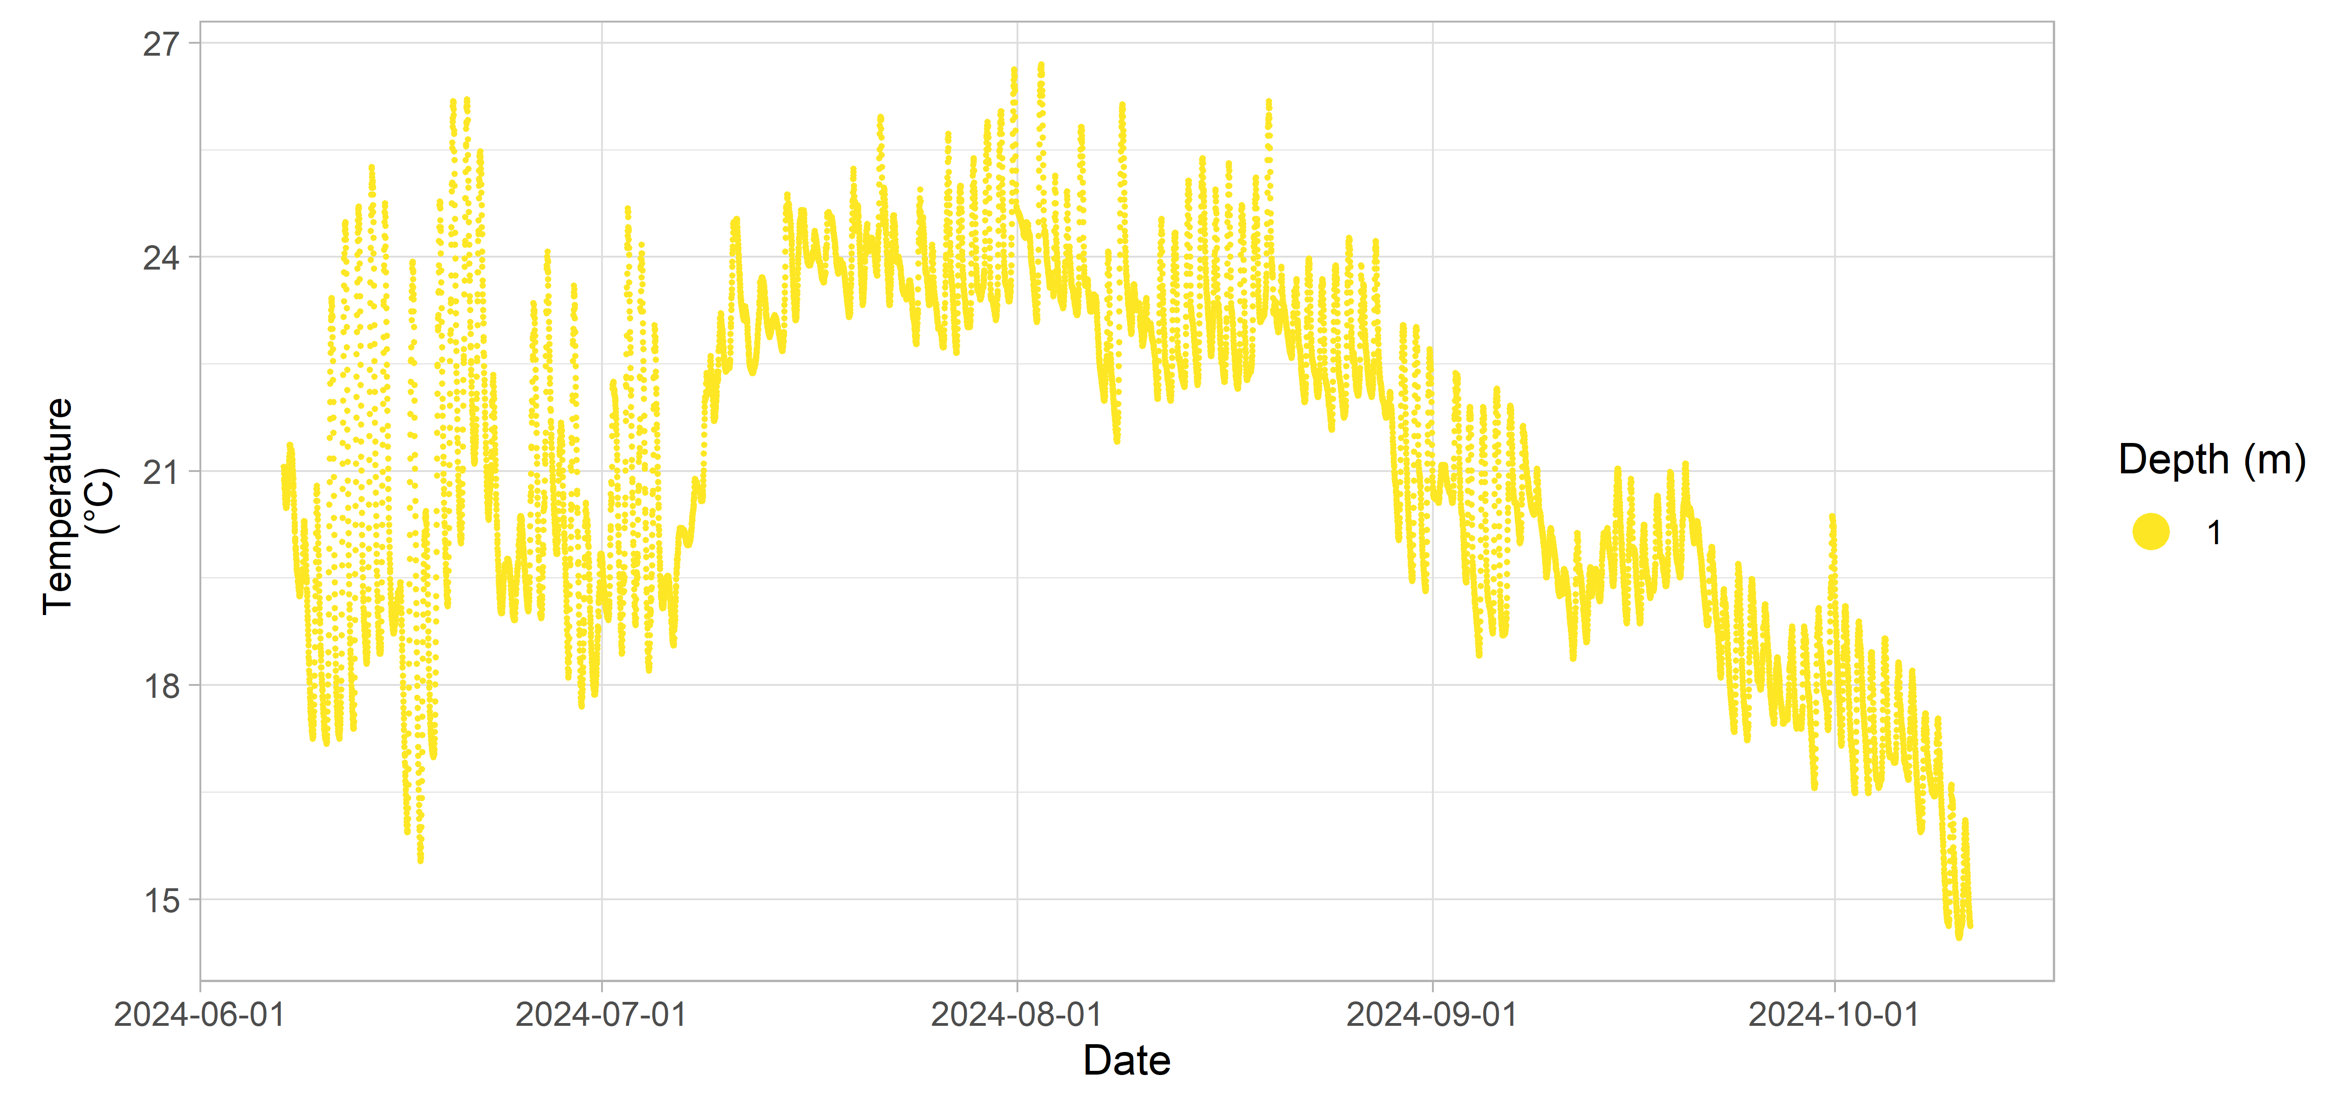**Figure 24:** Meteghan River 1 inland Water Quality data.

### Meteghan River 2

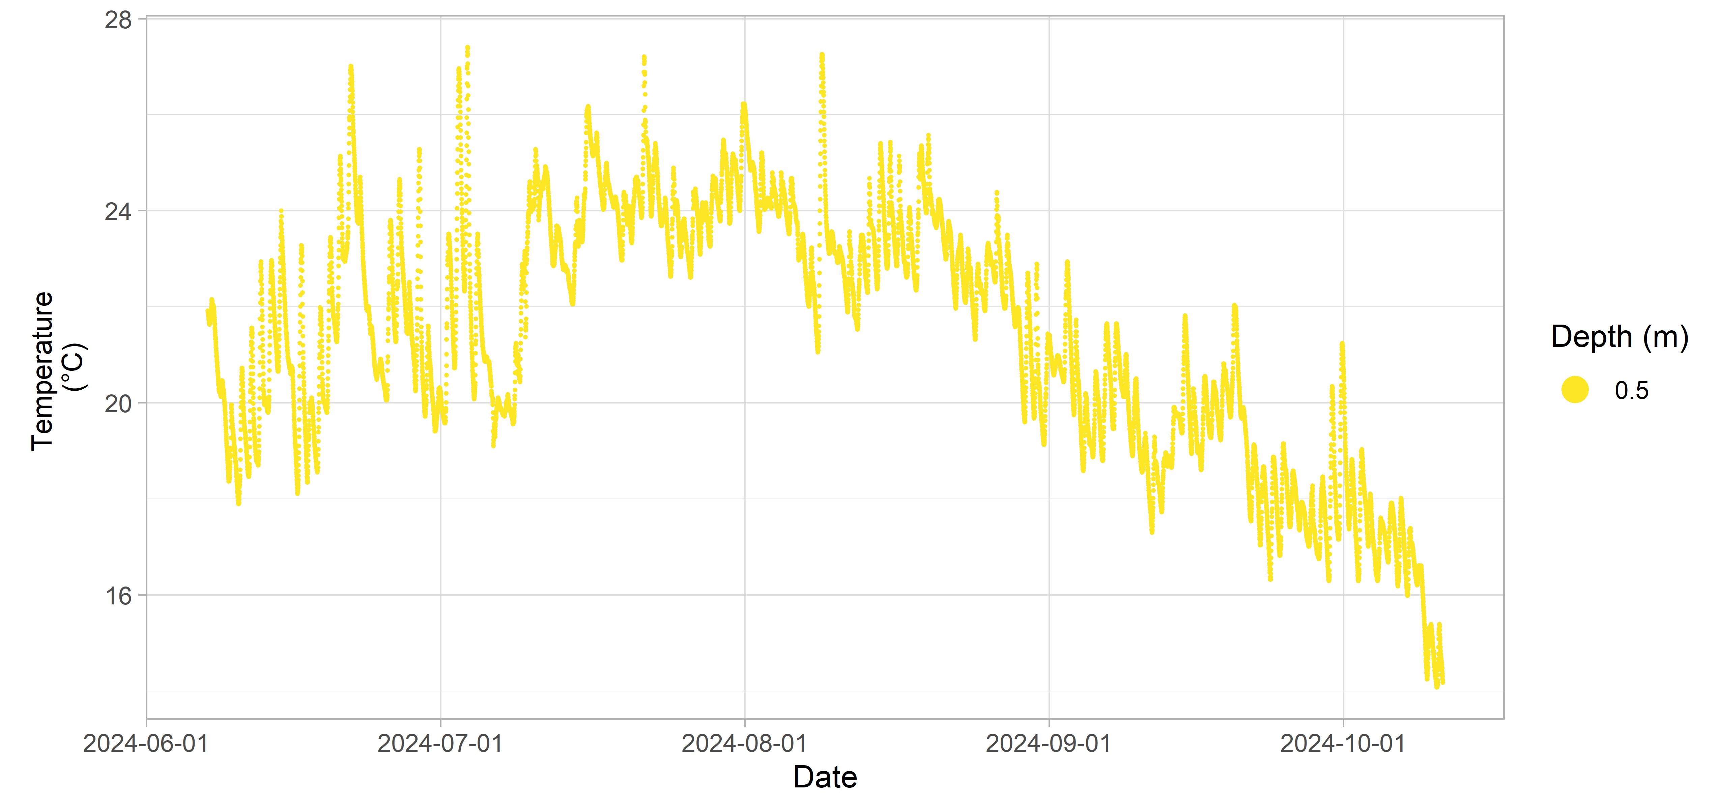**Figure 25:** Meteghan River 2 inland Water Quality data.

### Meteghan River 3

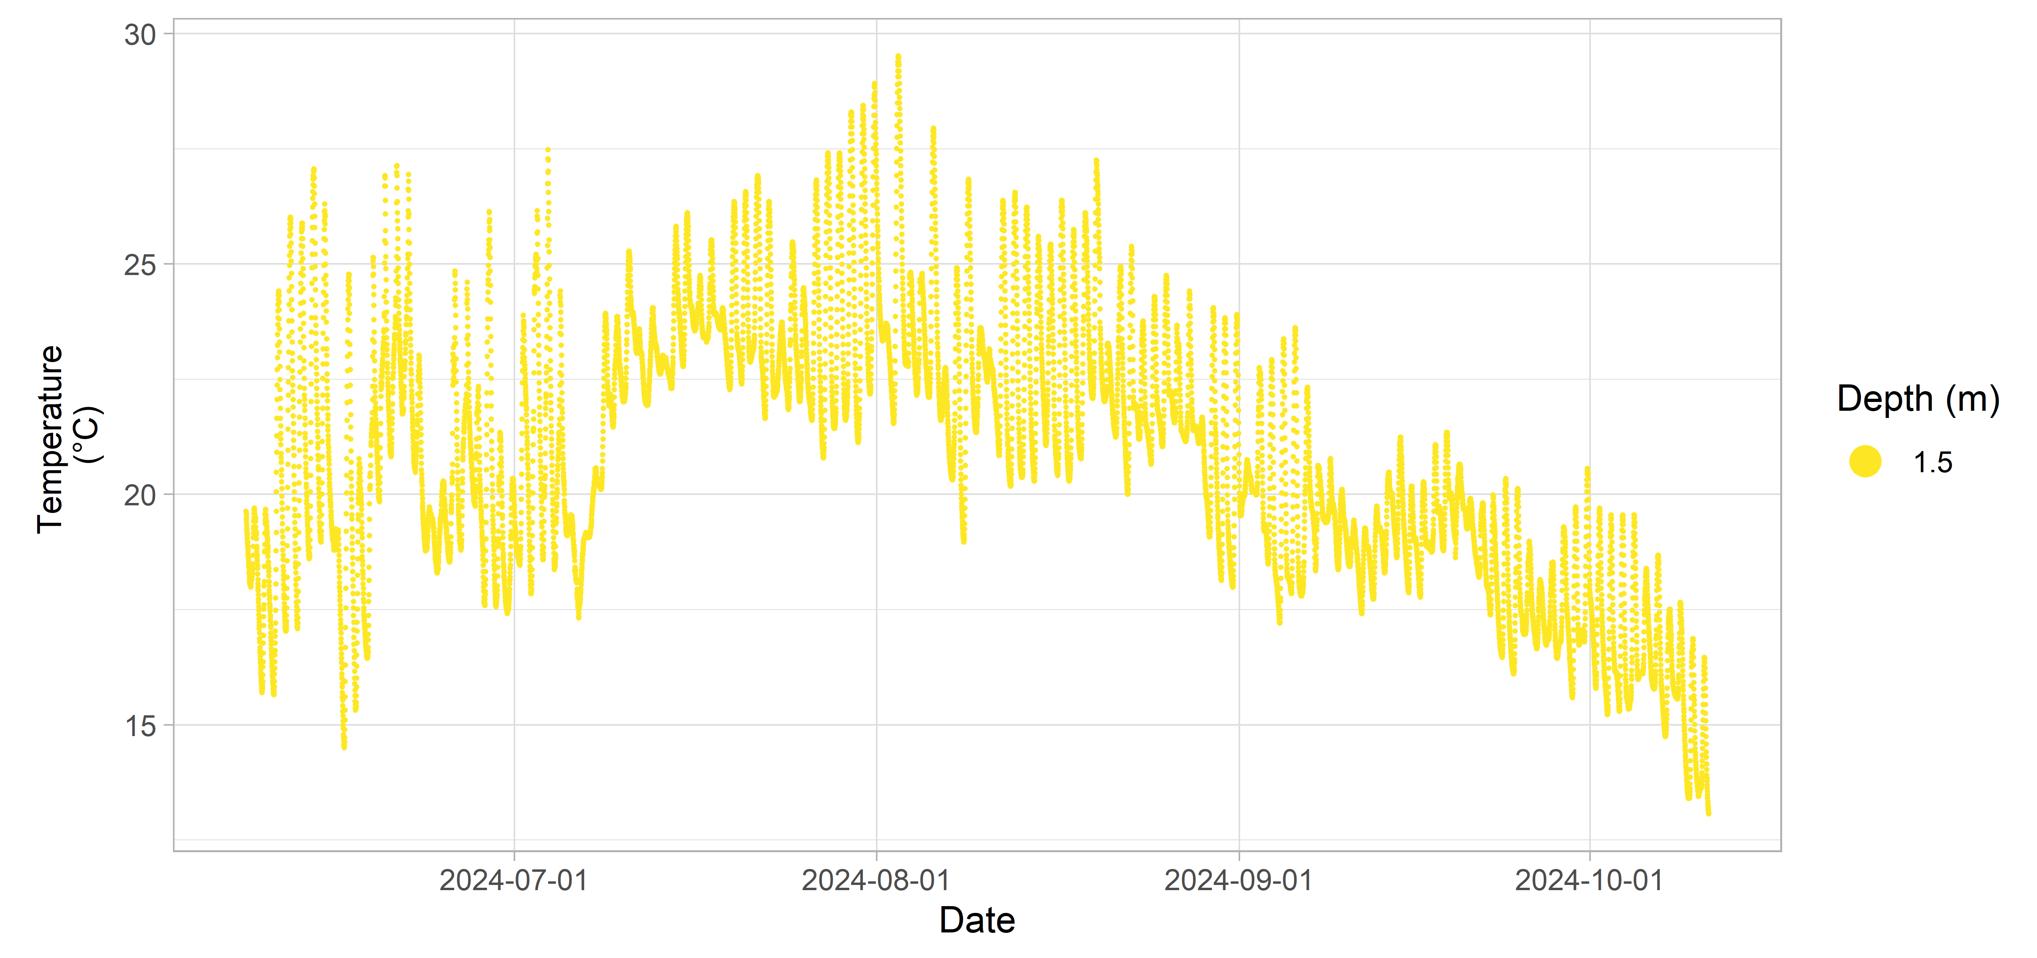**Figure 26:** Meteghan River 3 inland Water Quality data.

## Middle River

**Table 9:** Deployment details for Middle River.

| Station | Deployment Date | Retrieval Date | Latitude | Longitude | Configuration | Variables Measured |
| --- | --- | --- | --- | --- | --- | --- |
| Middle River 1 | 2024-06-11 | 2024-09-29 | 46.1555 | -60.9263 | attached to fixed structure | temperature |
| Middle River 2 | 2024-06-11 | 2024-09-29 | 46.1800 | -60.9215 | attached to fixed structure | temperature |
| Middle River 3 | 2024-06-11 | 2024-09-29 | 46.1296 | -60.9195 | attached to fixed structure | temperature |

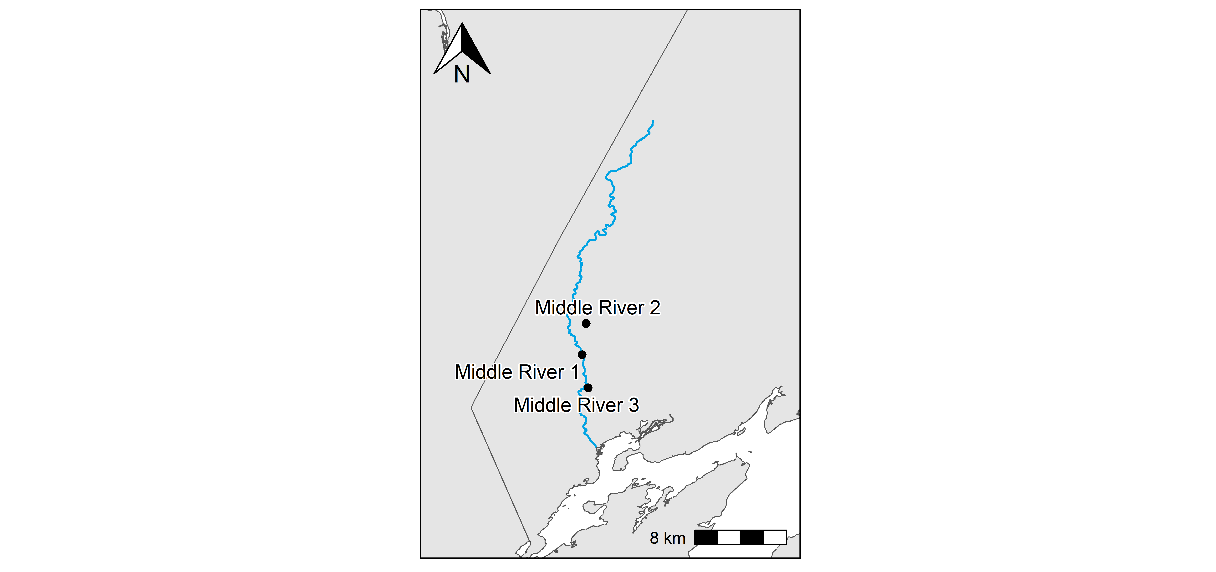**Figure 27:** Middle River station locations.

### Middle River 1

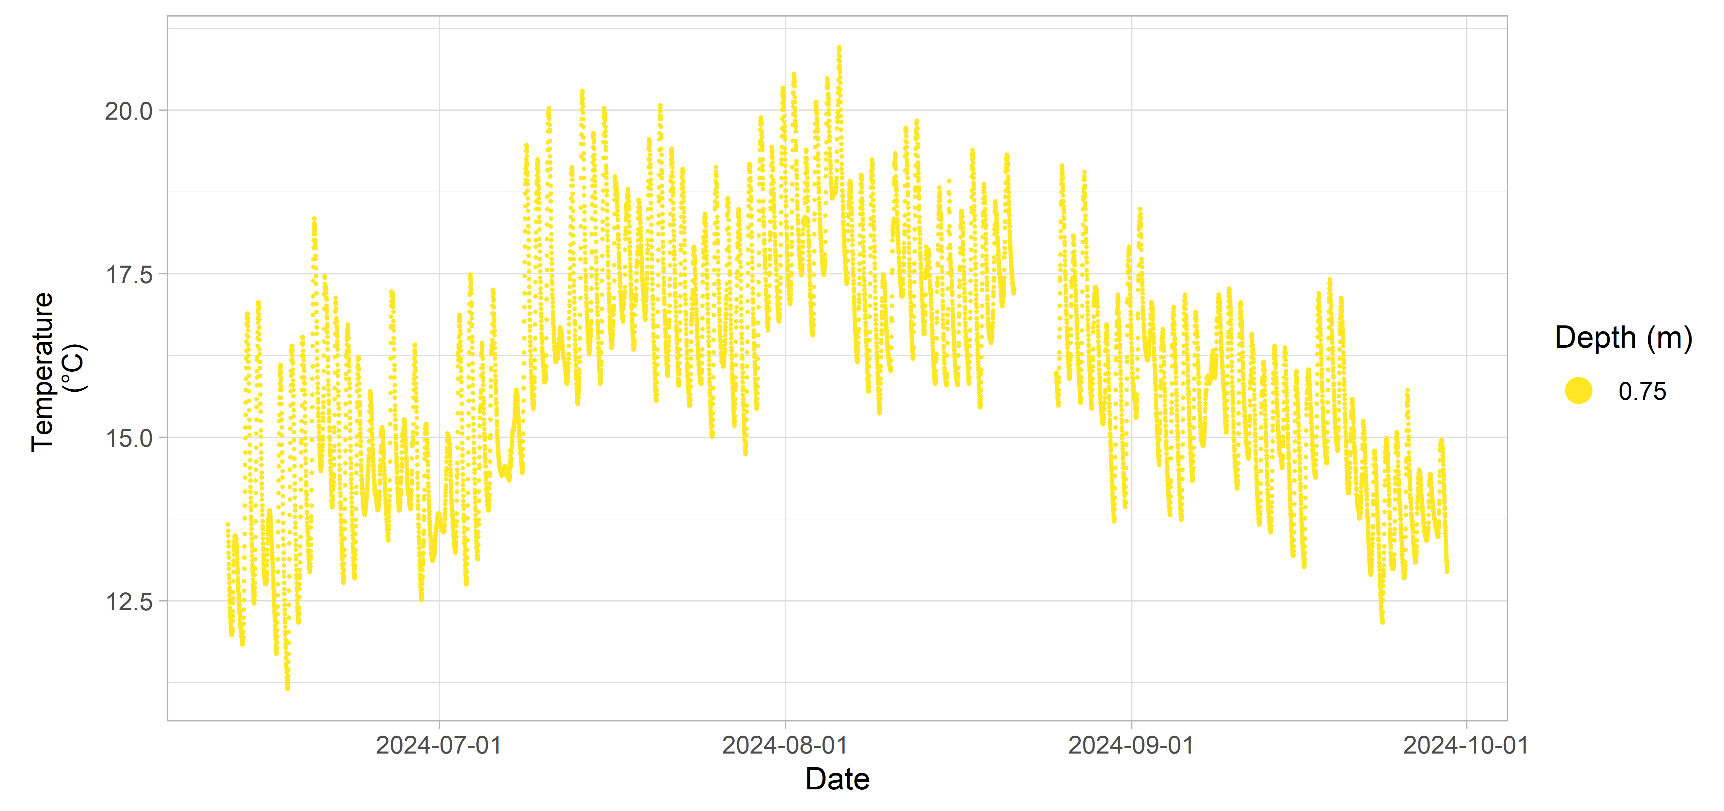**Figure 28:** Middle River 1 inland Water Quality data.

### Middle River 2

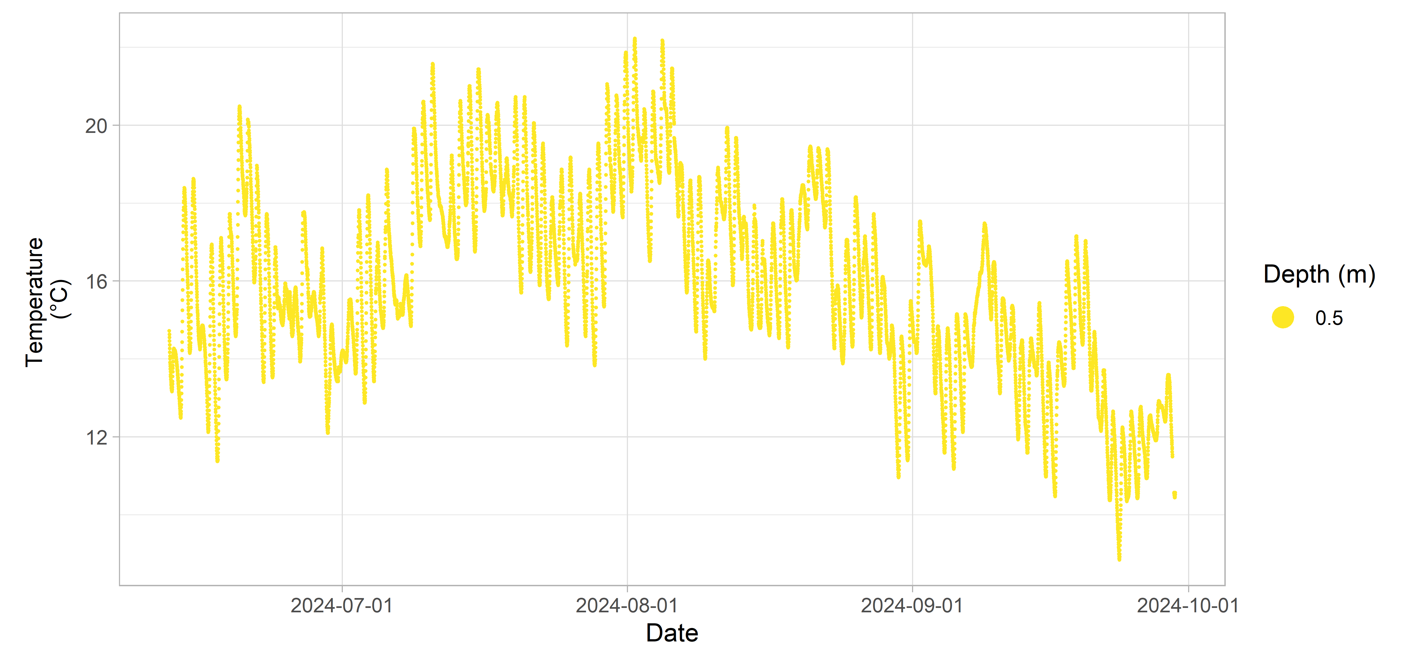**Figure 29:** Middle River 2 inland Water Quality data.

### Middle River 3

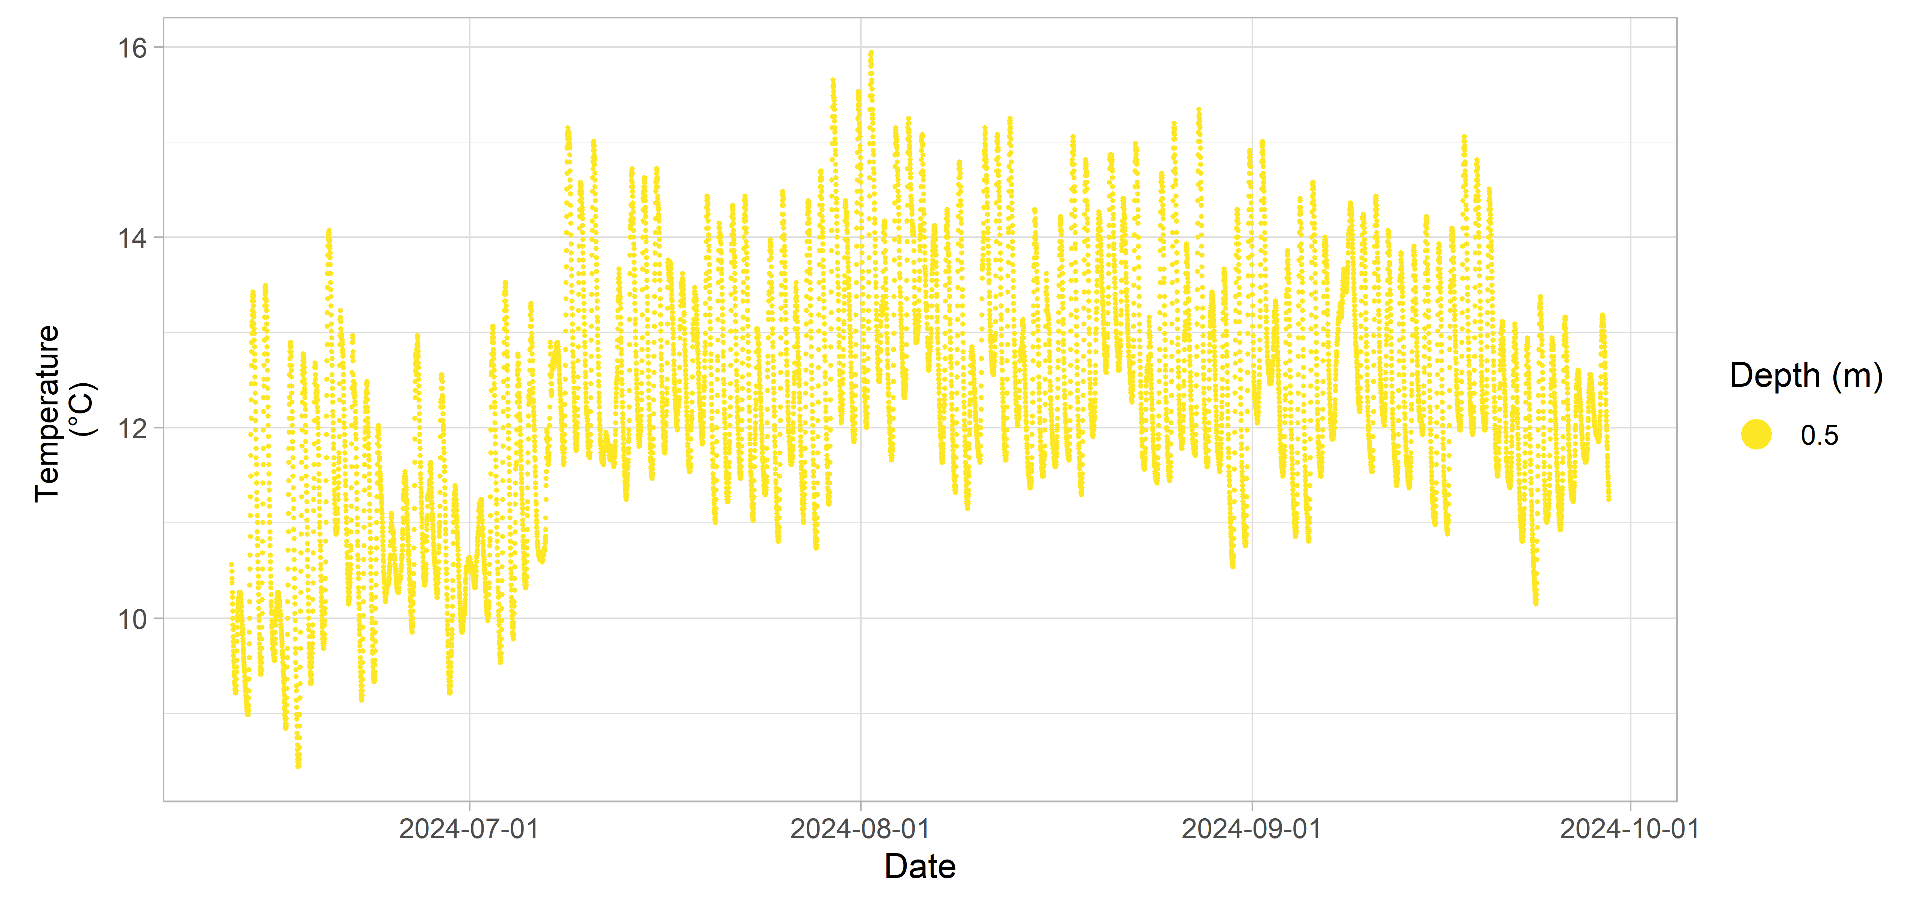**Figure 30:** Middle River 3 inland Water Quality data.

## Musquodoboit River

**Table 10:** Deployment details for Musquodoboit River.

| Station | Deployment Date | Retrieval Date | Latitude | Longitude | Configuration | Variables Measured |
| --- | --- | --- | --- | --- | --- | --- |
| Musquodoboit River 1 | 2023-07-07 | 2023-10-10 | 44.8719 | -63.2208 | attached to fixed structure | temperature |
| Musquodoboit River 2 | 2023-07-07 | 2023-10-10 | 44.9778 | -63.2247 | attached to fixed structure | temperature |
| Musquodoboit River 3 | 2023-07-07 | 2023-10-10 | 45.0821 | -63.0704 | attached to fixed structure | temperature |

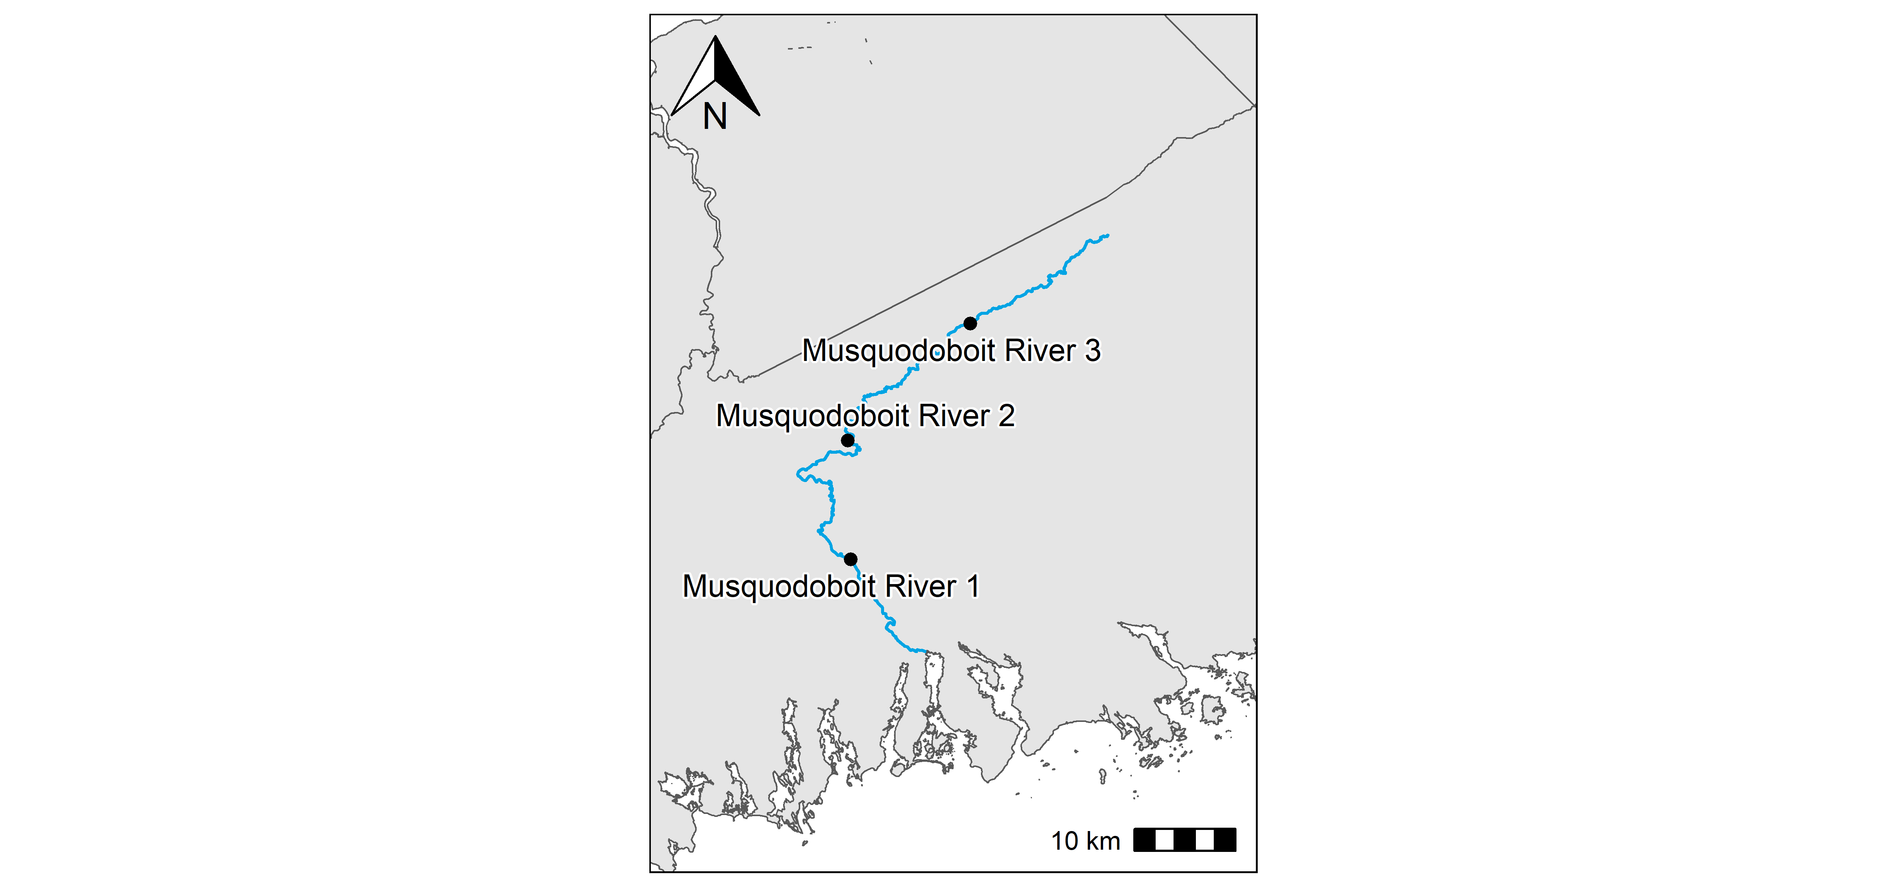**Figure 31:** Musquodoboit River station locations.

### Musquodoboit River 1

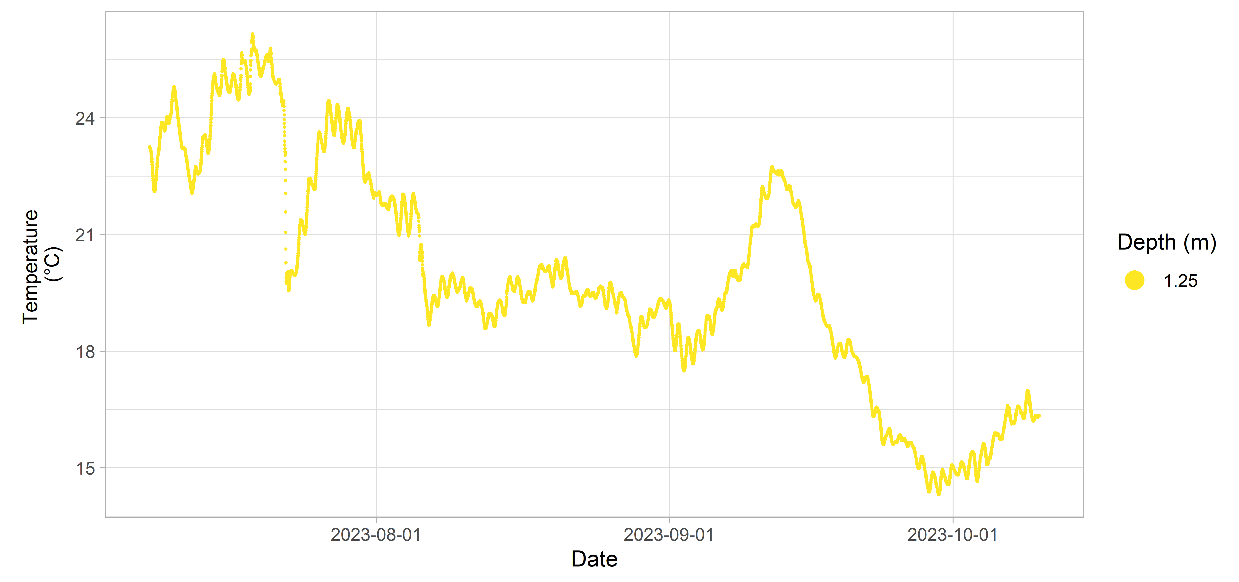**Figure 32:** Musquodoboit River 1 inland Water Quality data.

### Musquodoboit River 2

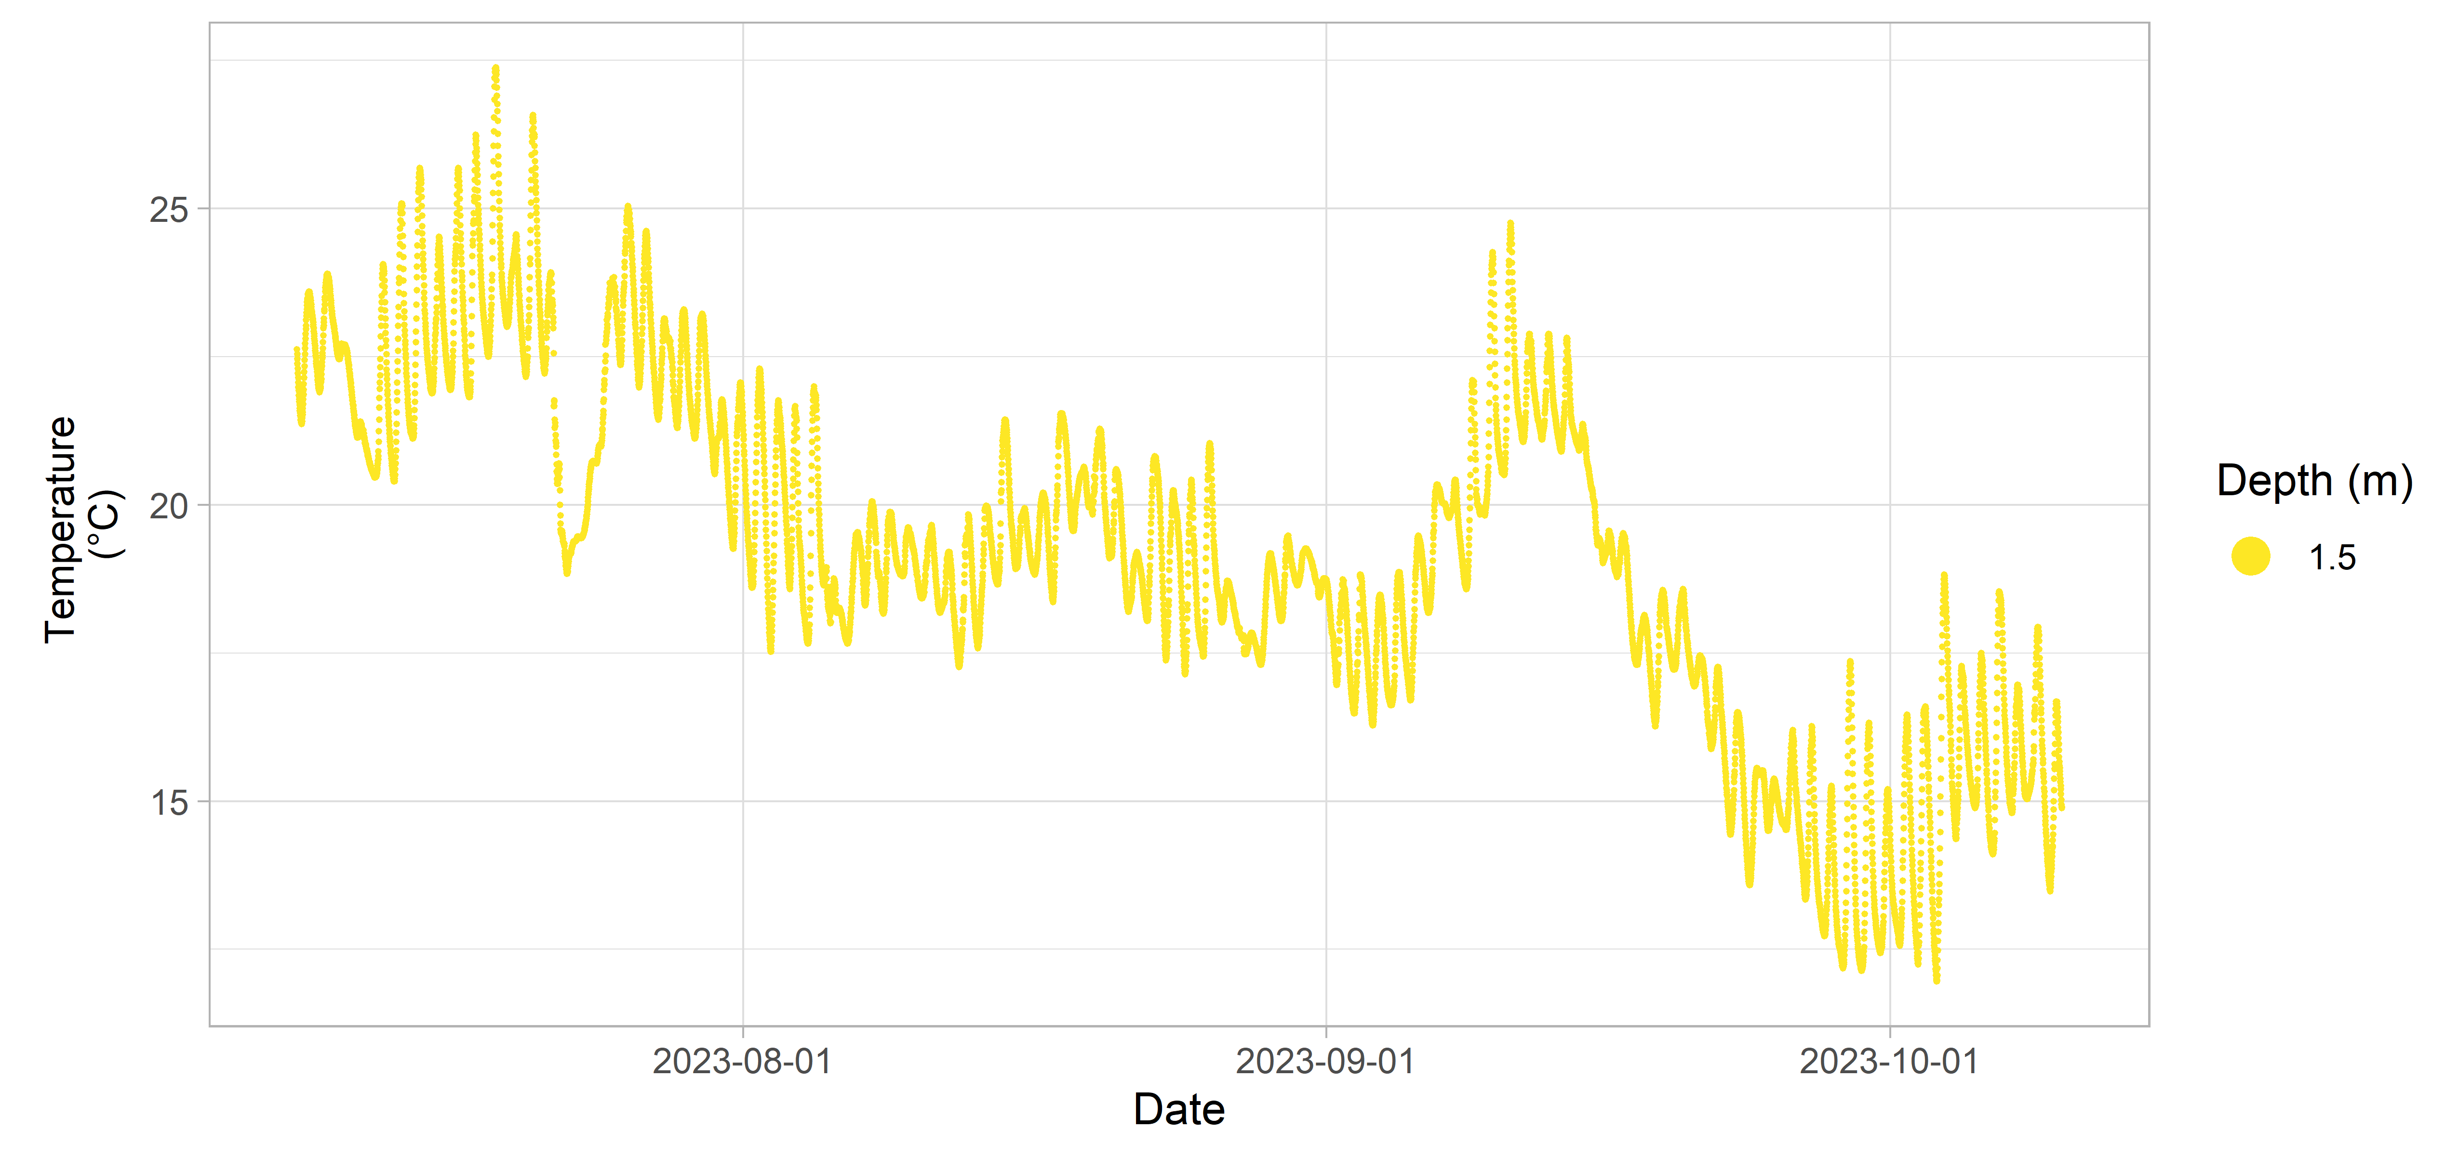**Figure 33:** Musquodoboit River 2 inland Water Quality data.

### Musquodoboit River 3

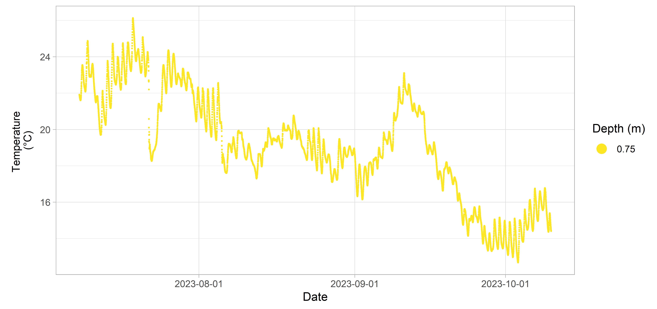**Figure 34:** Musquodoboit River 3 inland Water Quality data.

## North River

**Table 11:** Deployment details for North River.

| Station | Deployment Date | Retrieval Date | Latitude | Longitude | Configuration | Variables Measured |
| --- | --- | --- | --- | --- | --- | --- |
| North River 1 | 2024-06-11 | 2024-09-26 | 46.3167 | -60.6716 | attached to fixed structure | temperature |

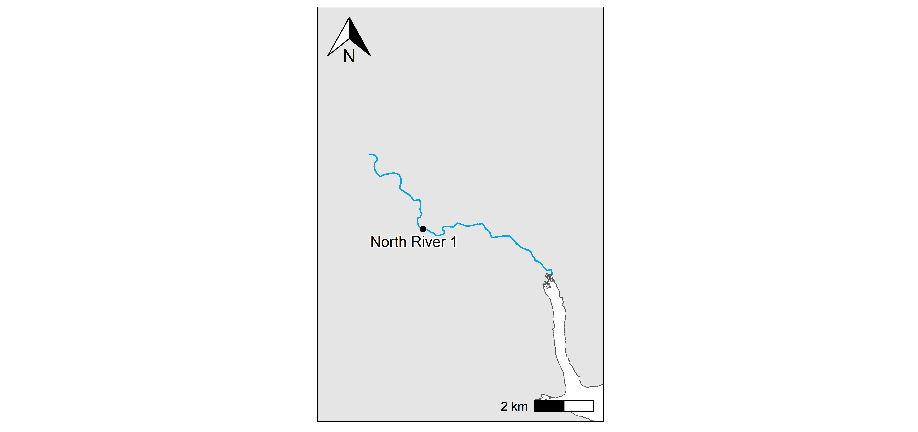**Figure 35:** North River station locations.

### North River 1

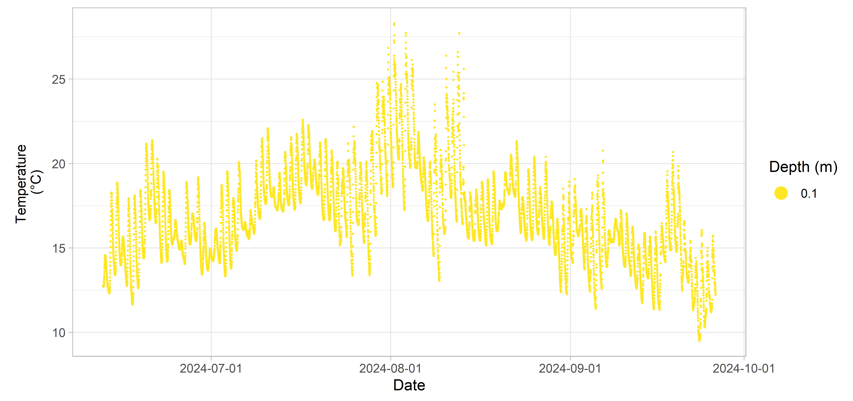**Figure 36:** North River 1 inland Water Quality data.

## Piper Lake

**Table 12:** Deployment details for Piper Lake.

| Station | Deployment Date | Retrieval Date | Latitude | Longitude | Configuration | Variables Measured |
| --- | --- | --- | --- | --- | --- | --- |
| Piper Lake | 2020-01-15 | 2020-05-14 | 45.3464 | -62.6609 | sub-surface buoy | dissolved oxygen (% sat) |
| temperature |  |  |  |  |  |  |

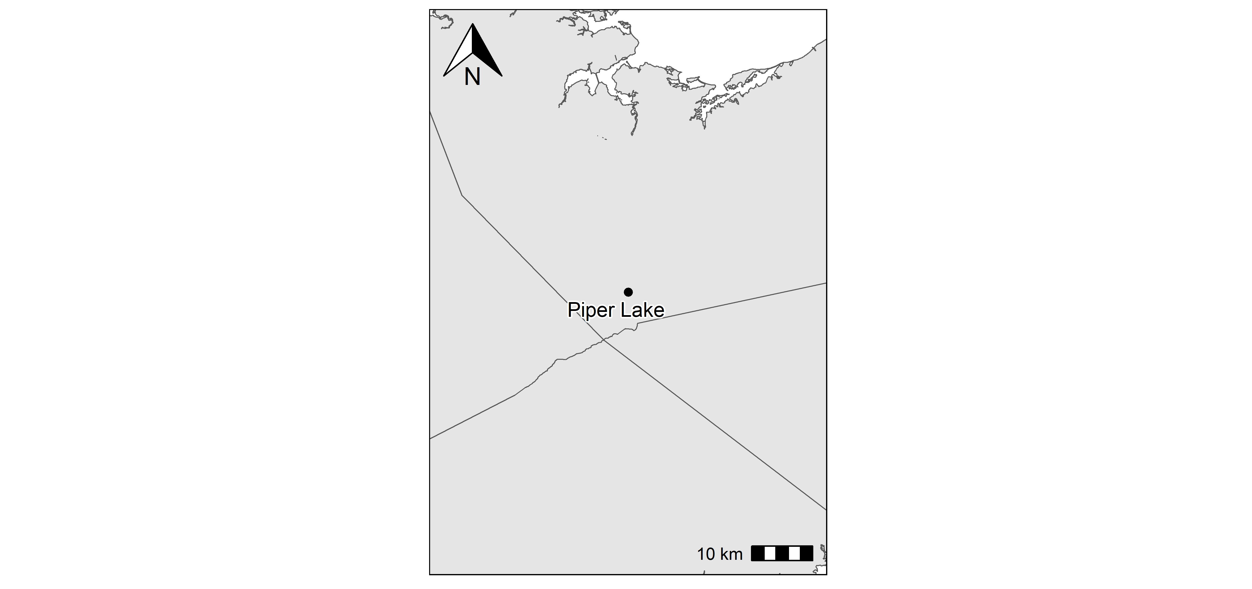**Figure 37:** Piper Lake station locations.

### Piper Lake

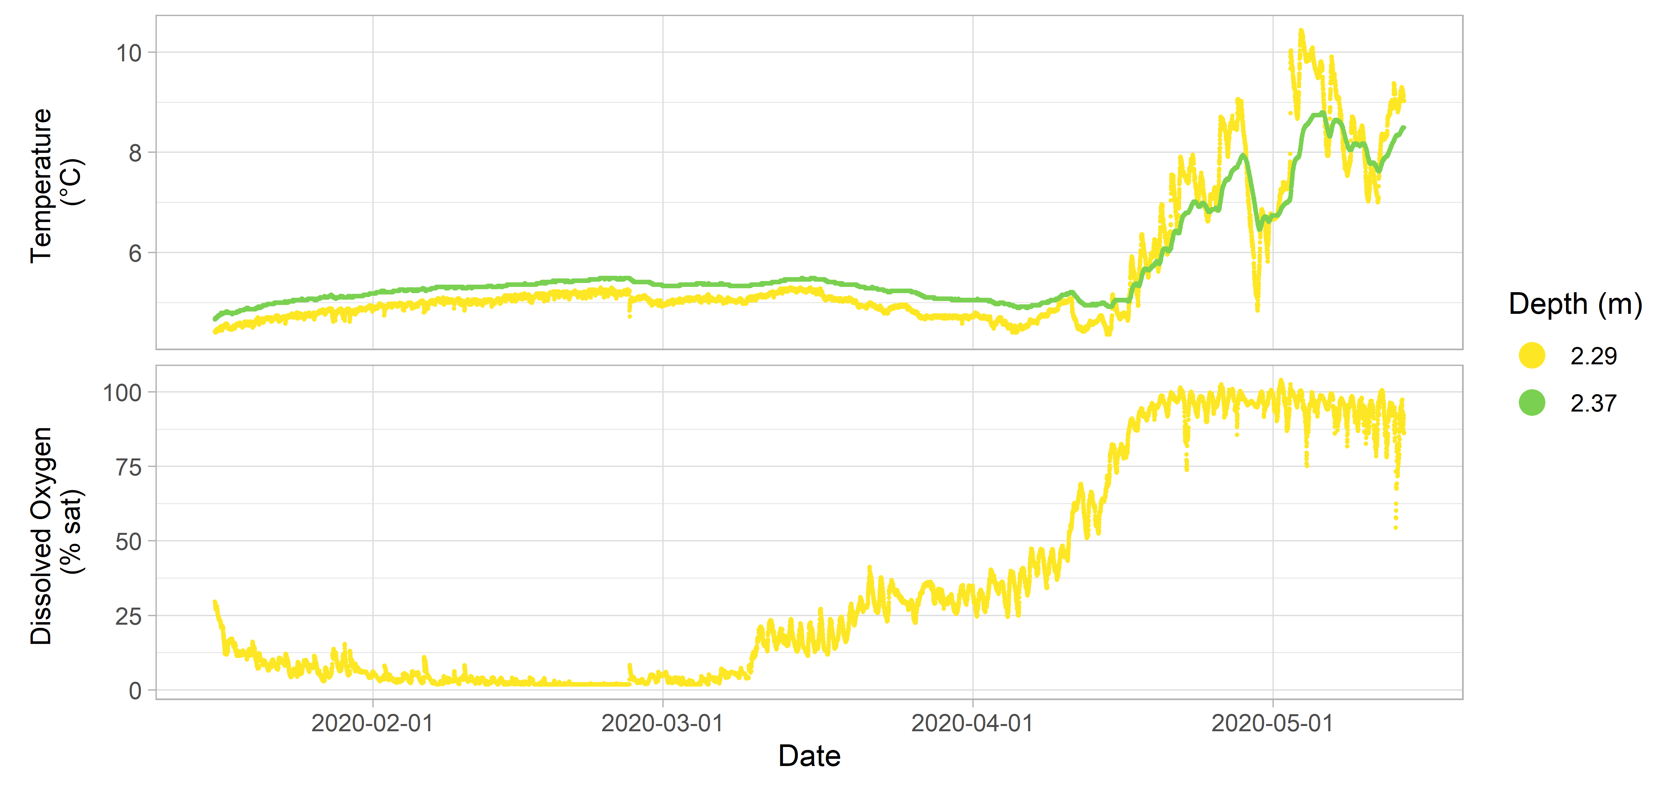**Figure 38:** Piper Lake inland Water Quality data.

## Roseway River

**Table 13:** Deployment details for Roseway River.

| Station | Deployment Date | Retrieval Date | Latitude | Longitude | Configuration | Variables Measured |
| --- | --- | --- | --- | --- | --- | --- |
| Roseway River 1 | 2023-06-29 | 2023-10-19 | 43.9800 | -65.4298 | attached to fixed structure | temperature |
| Roseway River 2 | 2023-06-29 | 2023-10-19 | 43.8497 | -65.3660 | attached to fixed structure | temperature |

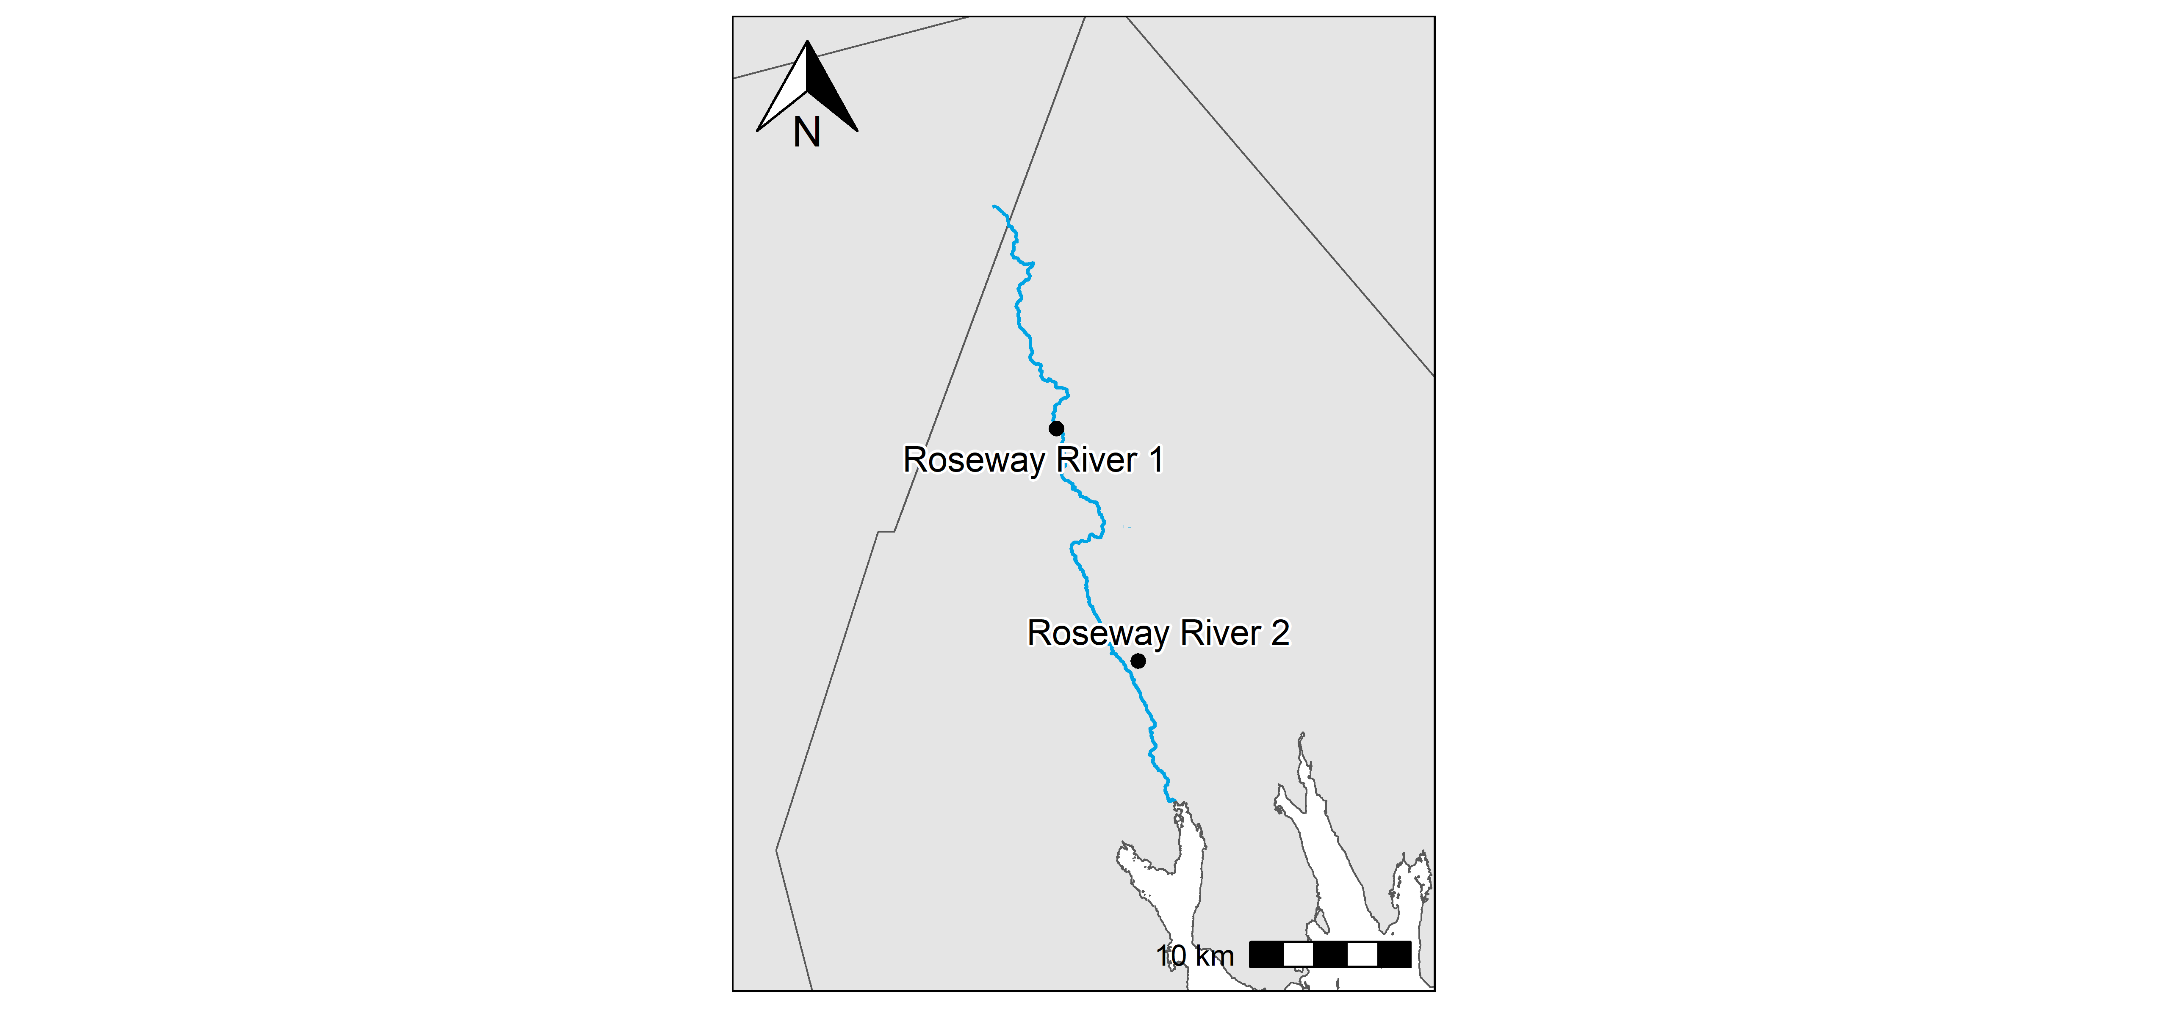**Figure 39:** Roseway River station locations.

### Roseway River 1

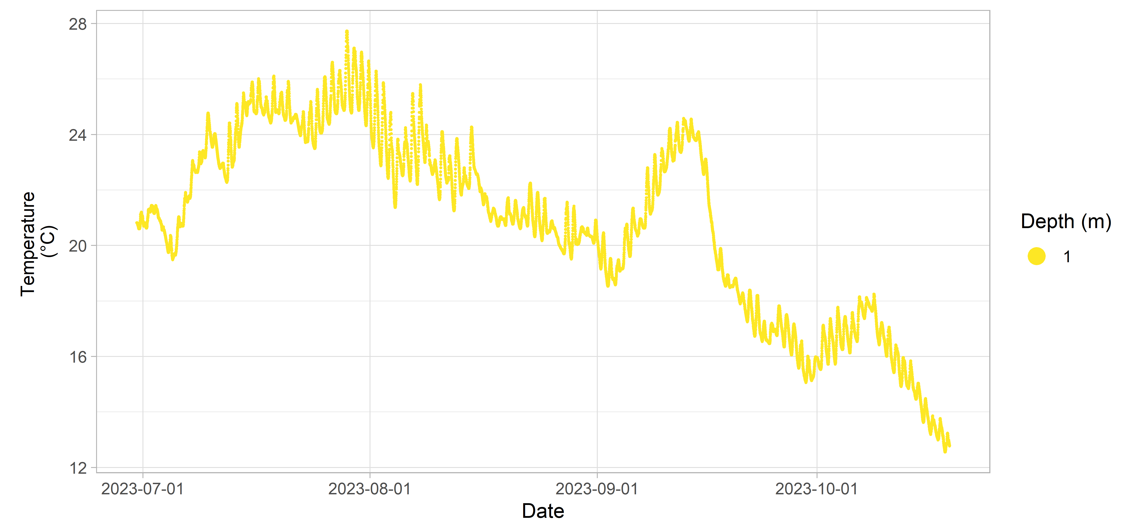**Figure 40:** Roseway River 1 inland Water Quality data.

### Roseway River 2

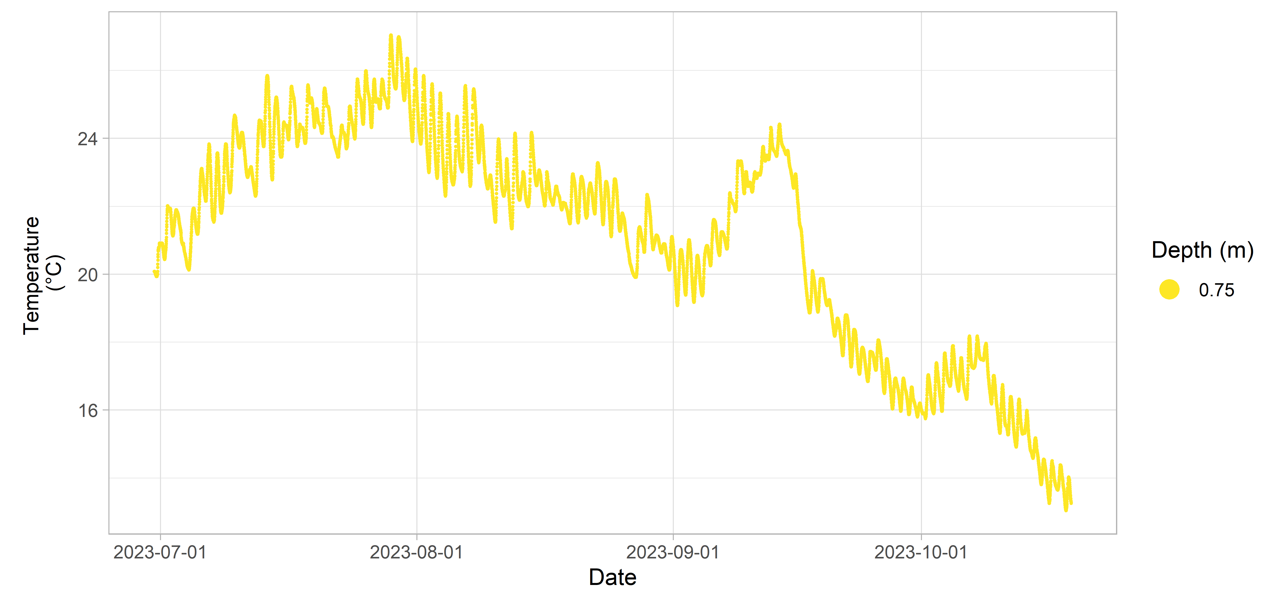**Figure 41:** Roseway River 2 inland Water Quality data.

## Round Hill River

**Table 14:** Deployment details for Round Hill River.

| Station | Deployment Date | Retrieval Date | Latitude | Longitude | Configuration | Variables Measured |
| --- | --- | --- | --- | --- | --- | --- |
| Round Hill River 1 | 2023-06-27 | 2023-09-29 | 44.7595 | -65.3994 | attached to fixed structure | temperature |
| Round Hill River 2 | 2023-06-27 | 2023-09-29 | 44.7123 | -65.3198 | attached to fixed structure | temperature |
| Round Hill River 3 | 2023-06-27 | 2023-09-29 | 44.7045 | -65.2908 | attached to fixed structure | temperature |

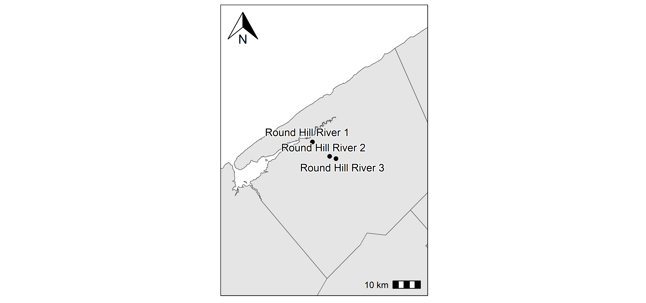**Figure 42:** Round Hill River station locations.

### Round Hill River 1

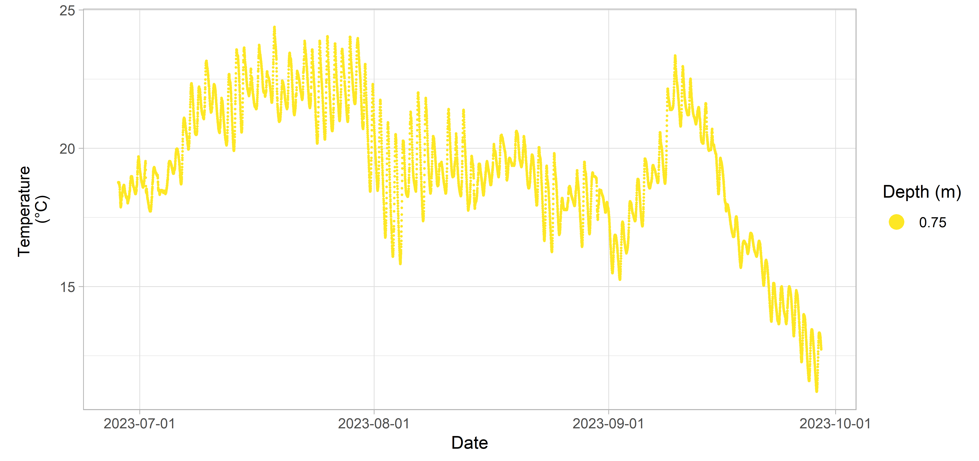**Figure 43:** Round Hill River 1 inland Water Quality data.

### Round Hill River 2

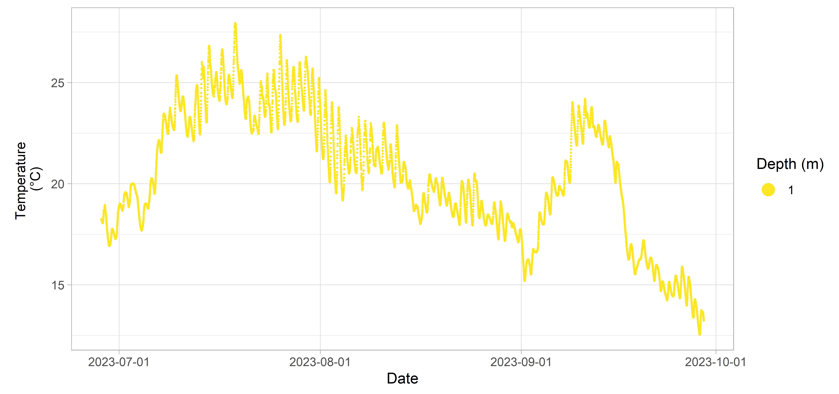**Figure 44:** Round Hill River 2 inland Water Quality data.

### Round Hill River 3

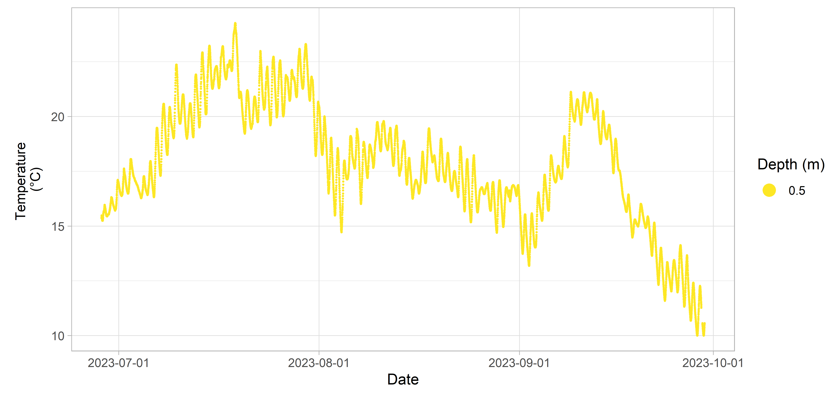**Figure 45:** Round Hill River 3 inland Water Quality data.

## Salmon River

**Table 15:** Deployment details for Salmon River.

| Station | Deployment Date | Retrieval Date | Latitude | Longitude | Configuration | Variables Measured |
| --- | --- | --- | --- | --- | --- | --- |
| Salmon River 1 | 2023-06-28 | 2023-10-18 | 44.1282 | -66.0648 | attached to fixed structure | temperature |
| Salmon River 2 | 2023-06-28 | 2023-10-18 | 44.1578 | -66.0278 | attached to fixed structure | temperature |

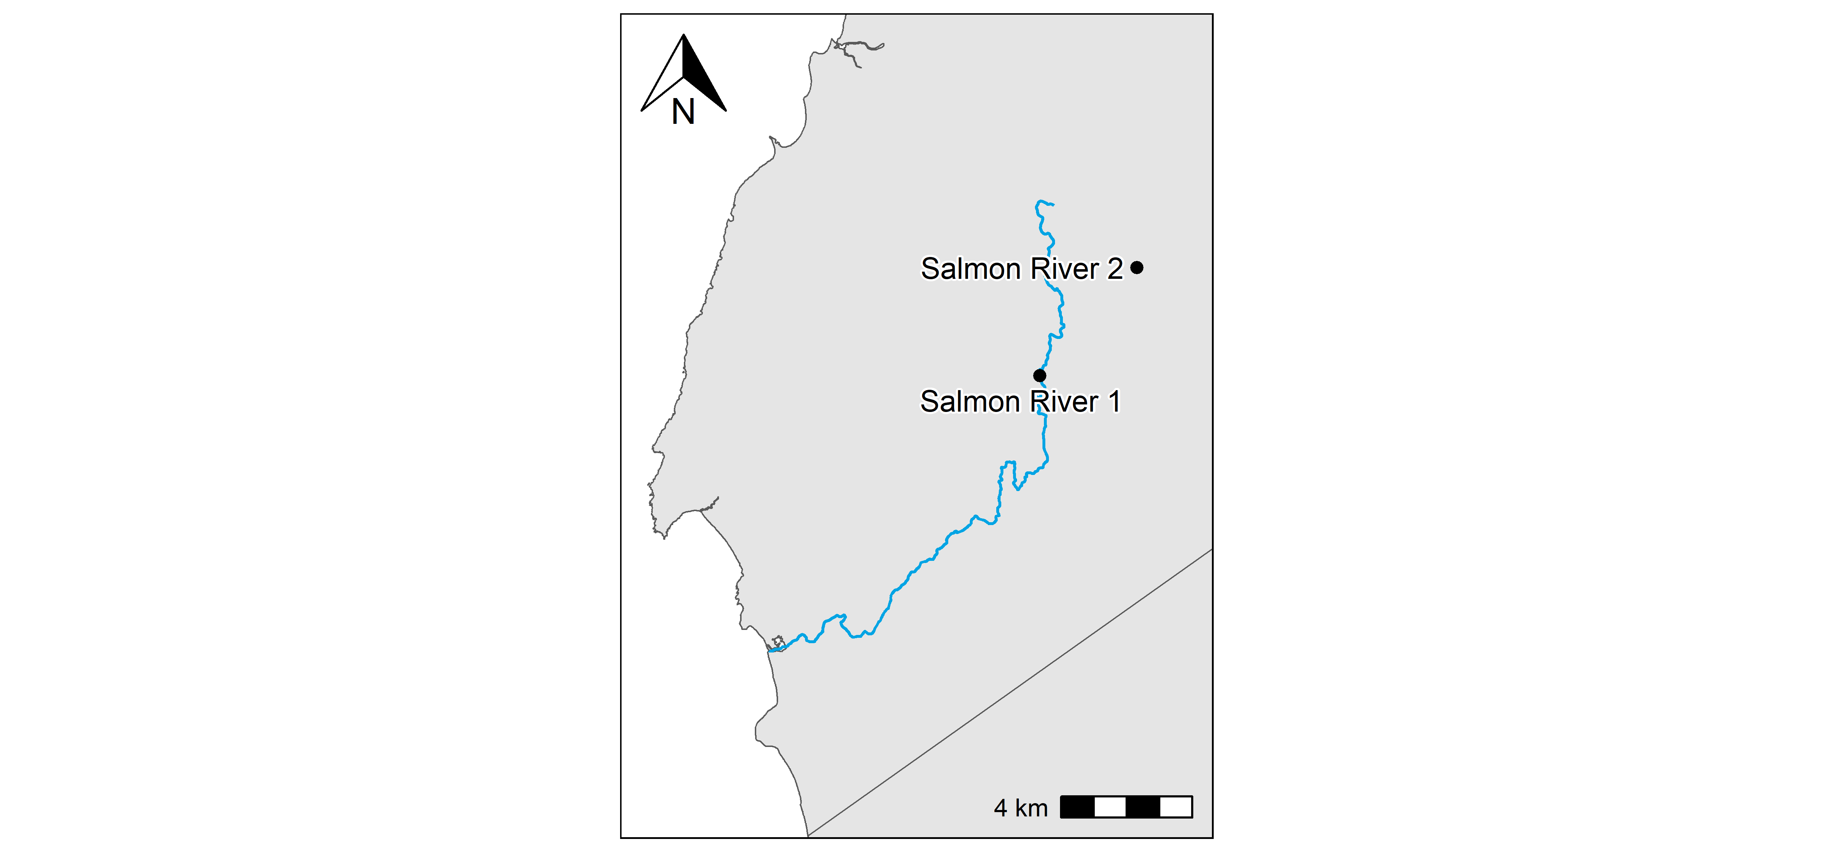**Figure 46:** Salmon River station locations.

### Salmon River 1

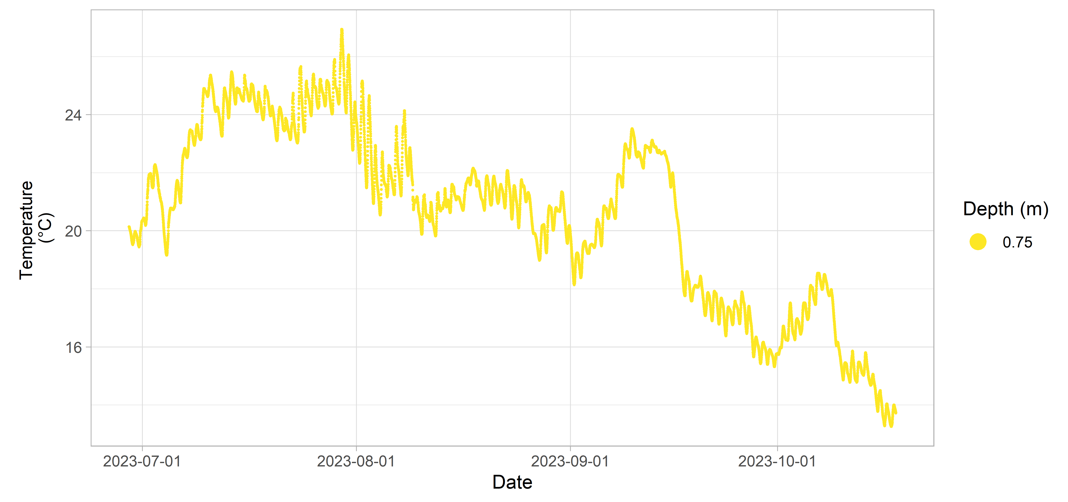**Figure 47:** Salmon River 1 inland Water Quality data.

### Salmon River 2

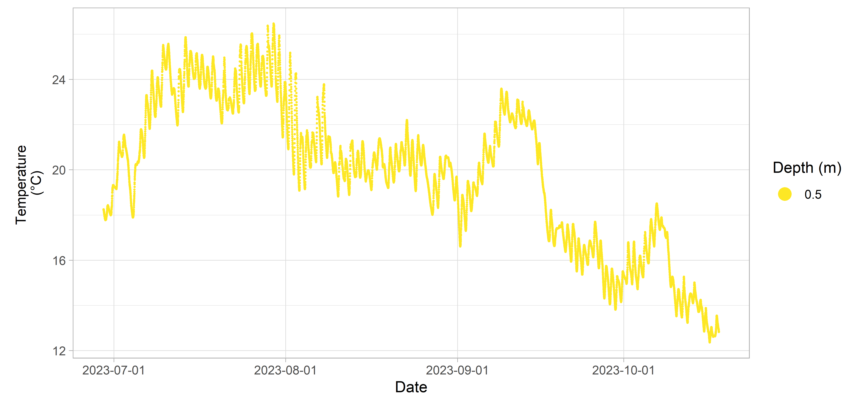**Figure 48:** Salmon River 2 inland Water Quality data.

## Sissiboo River

**Table 16:** Deployment details for Sissiboo River.

| Station | Deployment Date | Retrieval Date | Latitude | Longitude | Configuration | Variables Measured |
| --- | --- | --- | --- | --- | --- | --- |
| Sissiboo River | 2021-08-05 | 2021-11-08 | 44.4101 | -65.997 | floating dock | dissolved oxygen (% sat) |
| temperature |  |  |  |  |  |  |

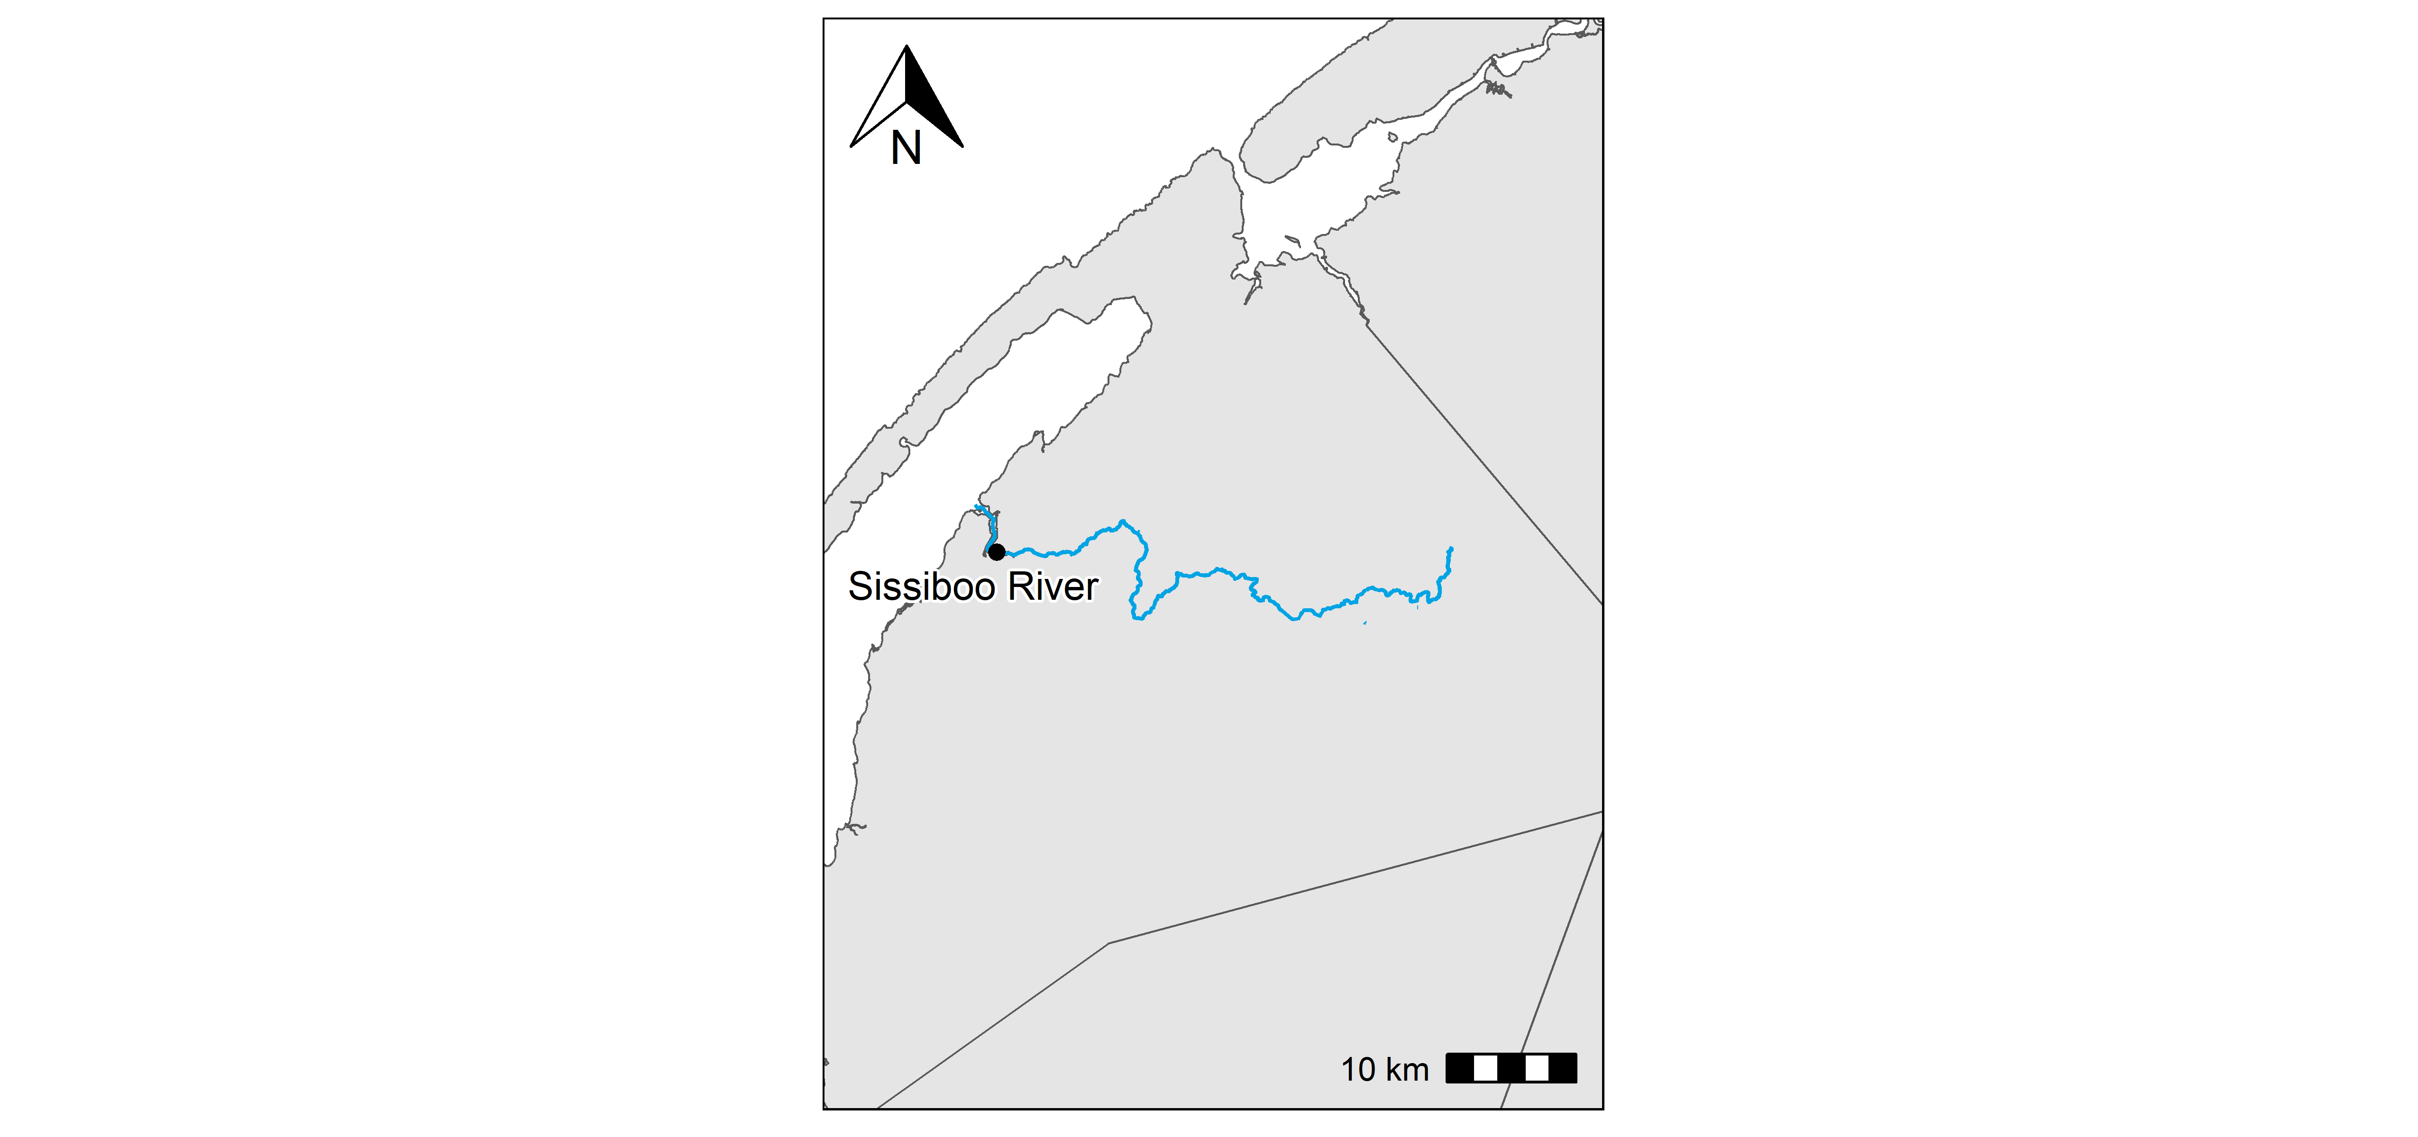**Figure 49:** Sissiboo River station locations.

### Sissiboo River

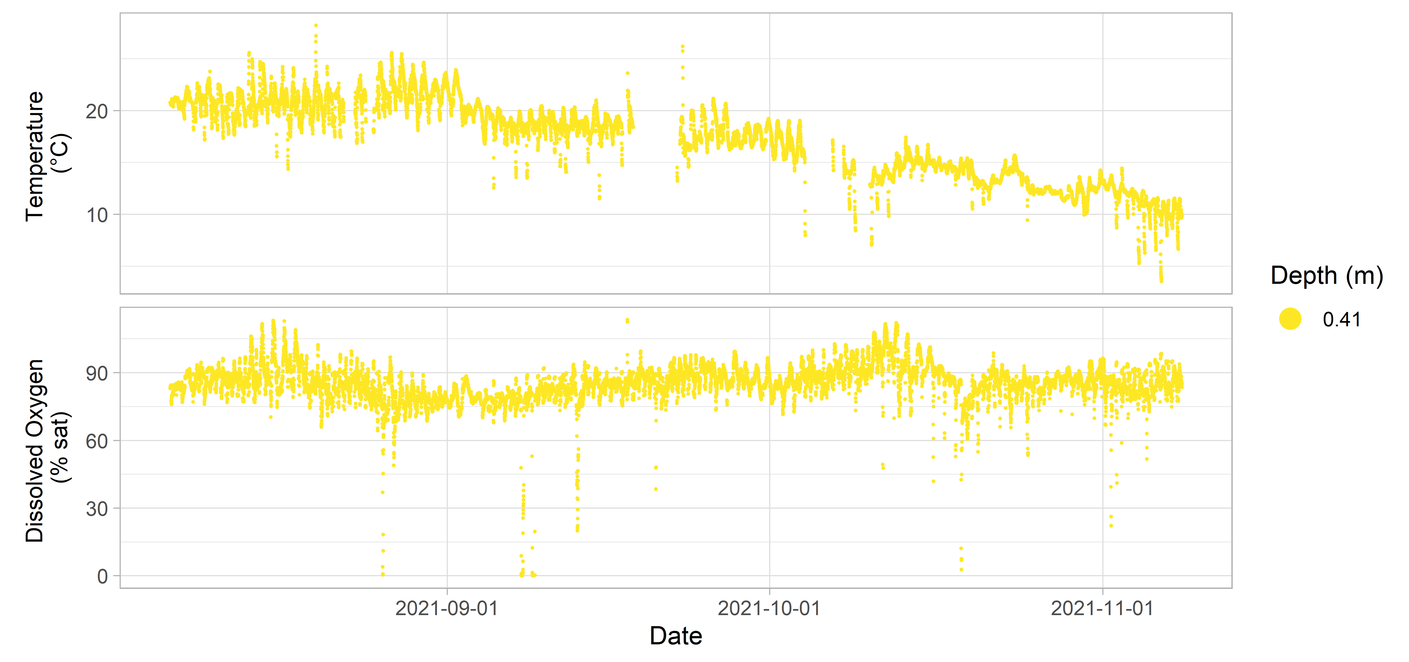**Figure 50:** Sissiboo River inland Water Quality data.

## Tusket River

**Table 17:** Deployment details for Tusket River.

| Station | Deployment Date | Retrieval Date | Latitude | Longitude | Configuration | Variables Measured |
| --- | --- | --- | --- | --- | --- | --- |
| Tusket River 1 | 2023-06-28 | 2023-10-18 | 44.0933 | -65.8036 | attached to fixed structure | temperature |
| Tusket River 2 | 2023-06-29 | 2023-10-19 | 43.8904 | -65.7717 | attached to fixed structure | temperature |
| Tusket River 3 | 2023-06-29 | 2023-10-18 | 44.1292 | -65.7301 | attached to fixed structure | temperature |

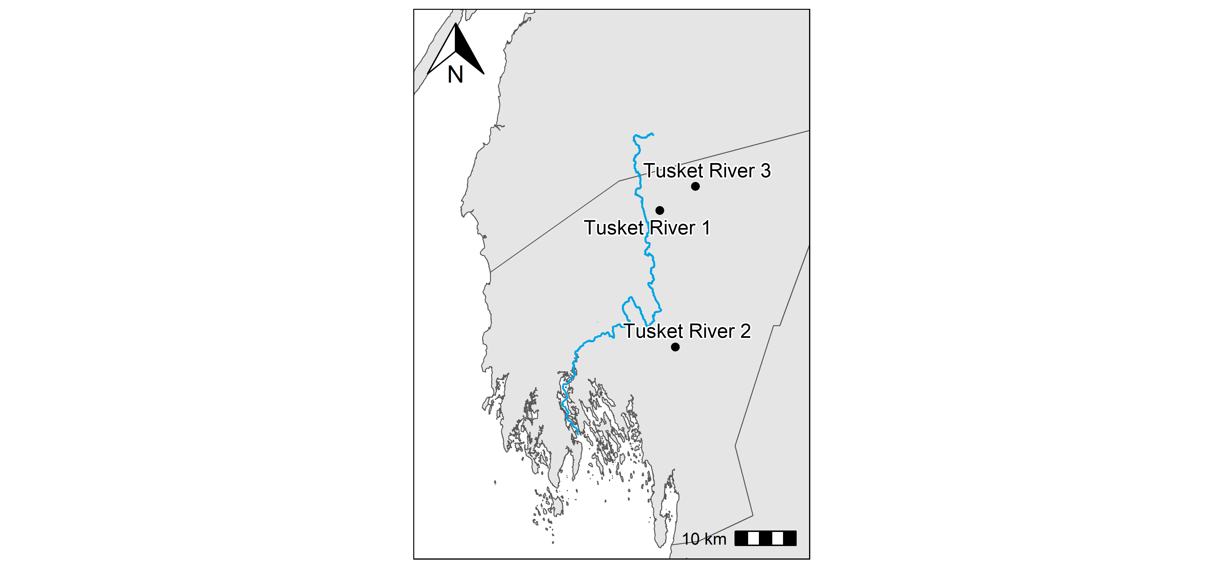**Figure 51:** Tusket River station locations.

### Tusket River 1

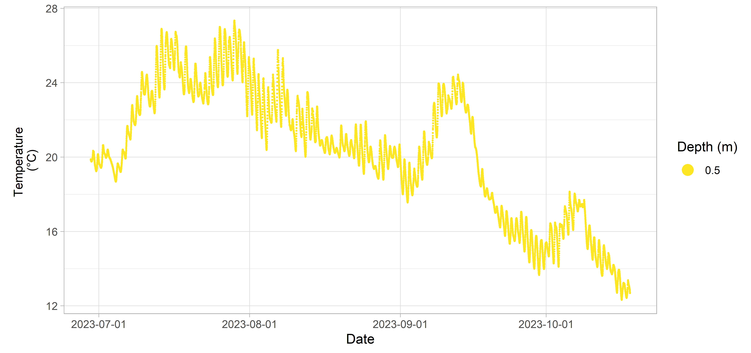**Figure 52:** Tusket River 1 inland Water Quality data.

### Tusket River 2

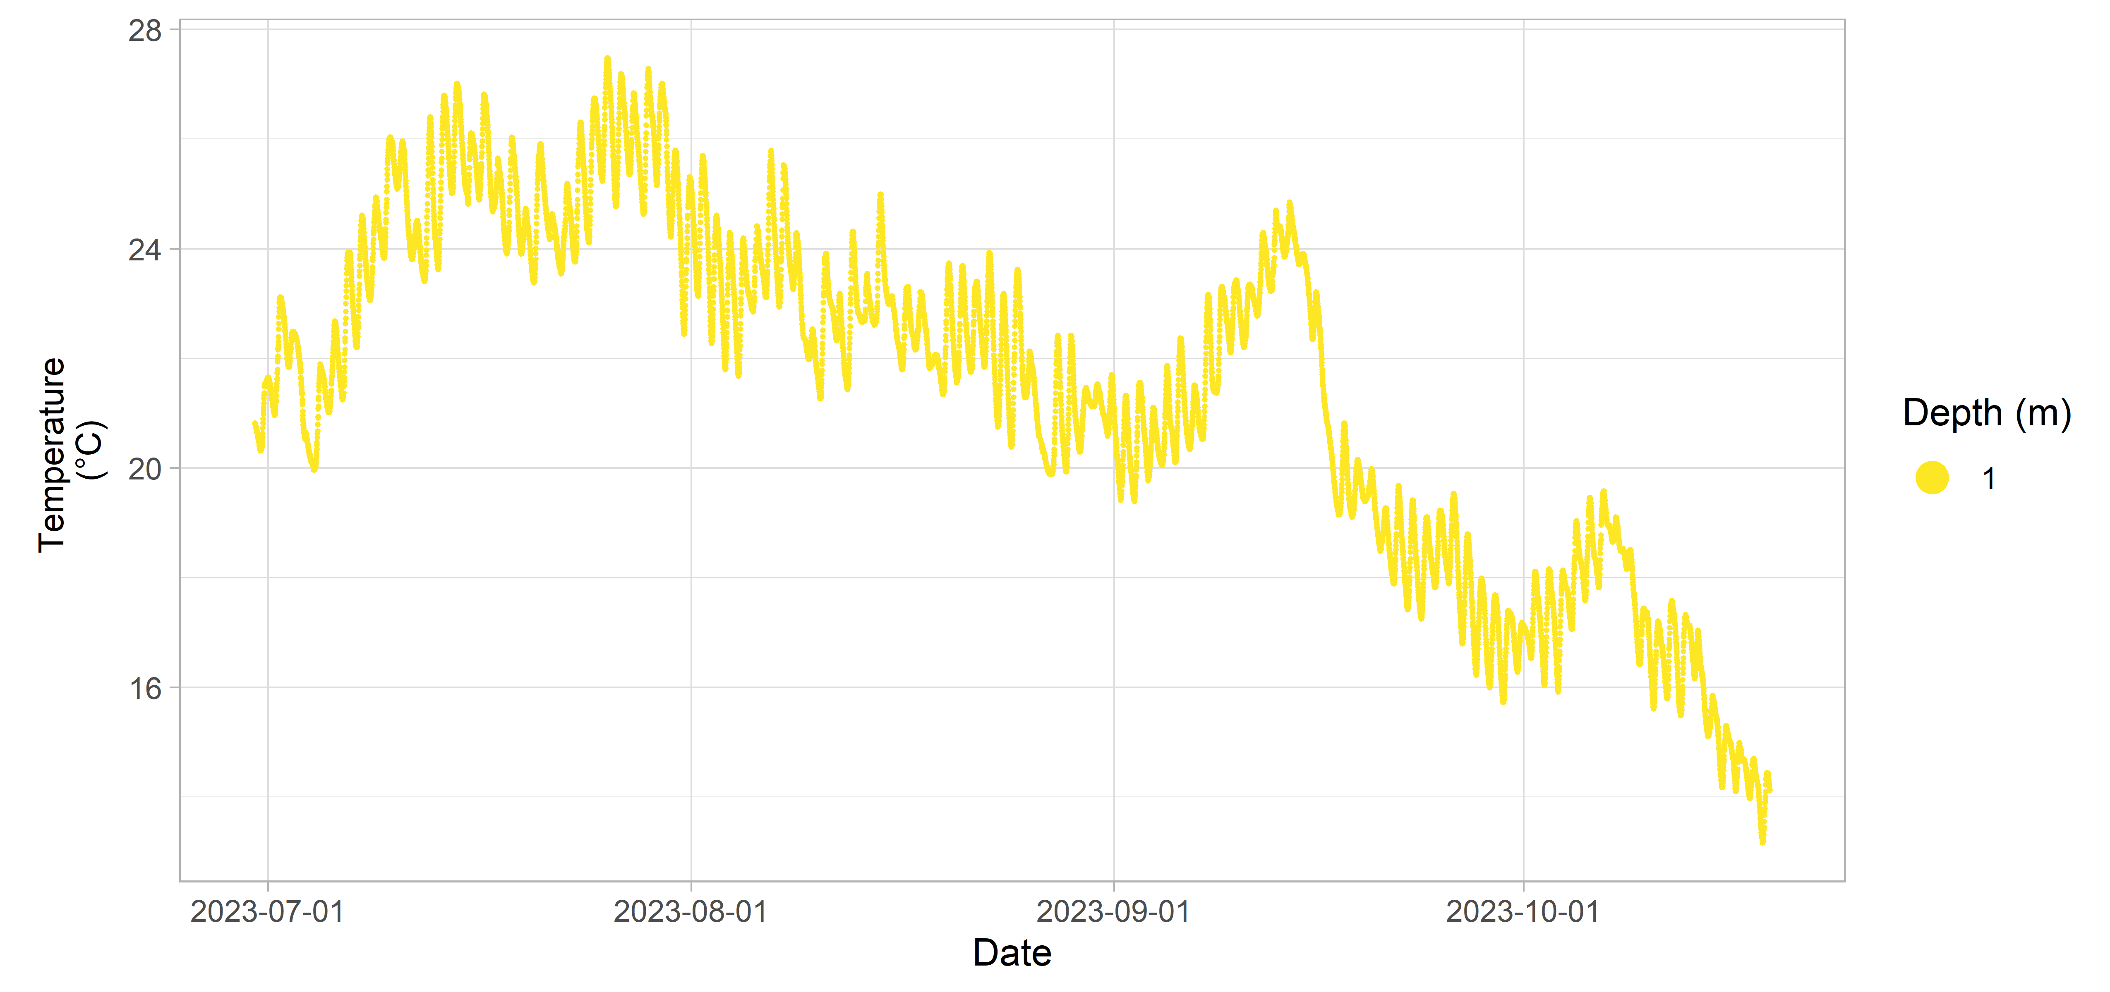**Figure 53:** Tusket River 2 inland Water Quality data.

### Tusket River 3

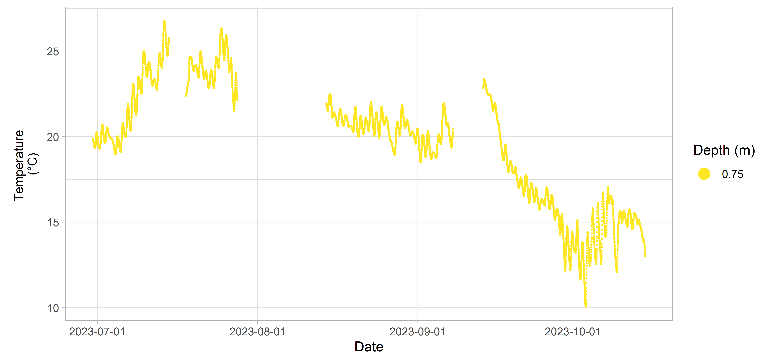**Figure 54:** Tusket River 3 inland Water Quality data.

# Data Acknowledgement

CMAR aims to prioritize data collection and processing efforts that best serve coastal interest holders. If you use this Coastal Monitoring Program Water Quality data in a project or for decision making, please complete our [anonymous questionnaire](https://docs.google.com/forms/d/1RmHN1vDaM0dXqKFKy8V-traIoubdw1pqMDKVtPmWDHc/edit) with your feedback. Please cite the report and/or datasets used.

# Document History

**Table 17:** Description of sensor string configurations.

| Version | Date | Amendments |
| --- | --- | --- |
| V1 | 2025-10-20 | New document |

# References

IOOS. 2020. “QARTOD Manual for Real-Time Oceanographic Data Quality Control Flags.” <https://cdn.ioos.noaa.gov/media/2020/07/QARTOD-Data-Flags-Manual_version1.2final.pdf>.

1. Some aquaculture gear may be sunk to the bottom during winter or extreme weather conditions like hurricanes, and so the sensor depth may change during the deployment. This change would likely be flagged by quality control processes, but it is recommended that users critically review data from these deployments.